**WEB DESIGN**

**PROJECT REPORT**

**V6.01**

|  |  |
| --- | --- |
| **Team K** | |
| **Student No.** | **Student Names** |
| **X20157511** | **Sinead Bradley** |
| **X20153155** | **Rob Gardner** |
|  |  |

Sinead’s CSS file deployed version

[Bean & Gone Coffee (sinead-dotcom.github.io)](https://sinead-dotcom.github.io/beanAndGoneCoffee/index.html)

Rob’s CSS file deployed version

[Home Bean & Gone (sinead-dotcom.github.io)](https://sinead-dotcom.github.io/beanAndGone/)

# Overview

The idea was one of a coffee shop with the following features:

* In-store & Online experience
* Informational and e-commerce pages:
  + In-store menu
  + Subscription options
  + Coffee appliances & merchandise
  + Wholesale
* Serving three types of customers
  + Cuppa Joe
  + Flat White Fred
  + Wholesale Helen

Early ideas for branding included the following:

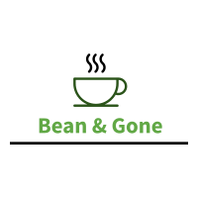

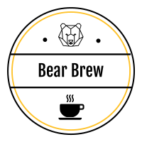

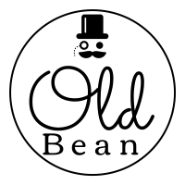

We chose this idea as we both liked coffee, we quickly generated a lot of ideas on the topic and found it interesting to proceed. We both agreed on the basic business model and look and feel of the site early on.

As we were asked to do an individual CSS file for the common pages and have an integrated look and feel we came up with our own individual look. Rob went with a “Green” contrast and Sinead with an “orange” contrasting color. Here are the final logo’s reflecting the looks.



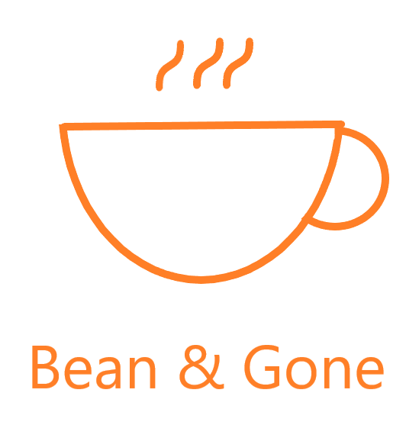

The scope of the project included the following pages:

As there was not enough time to do individual pages for Privacy and Cookie Policies we integrated this into the FAQ page. On the wish list was a product page working across the site with cookies and a basket.

# Design

## Research / Investigation

### Competitors & Market

Initially we researched 3 competitors:

* 3fe [www.3fe.com](http://www.3fe.com)
* Coffeewerk + Press [www.coffeewerkandpress.com](http://www.coffeewerkandpress.com)
* Upside Coffee [www.upsidecoffee.com](http://www.upsidecoffee.com)

The business model was similar across all three companies. Each company sells coffee beans and various pre-ground options. Several sell coffee equipment and merchanise (t-shirts, mugs, books). Content was minimalist however additional learning options are provided with brew guides and onsite training (including Barista training courses). Each also provide a subscription service so that you can have freshly ground coffee delivered straight to your door.

What distinguishes these sites? The products that they sell are high quality, branded and select. This is reflected in the polish and beauty of these 3 websites. The lines are crisp – square not rounded. The colour schemes include black, white and colour in citrus orange and lemon/mustard. A beige/off-white is used to pull the items from the background. This is a sophisticated, classy look – no fuss. Lovely use of white space. All items have a crisp picture of each product.

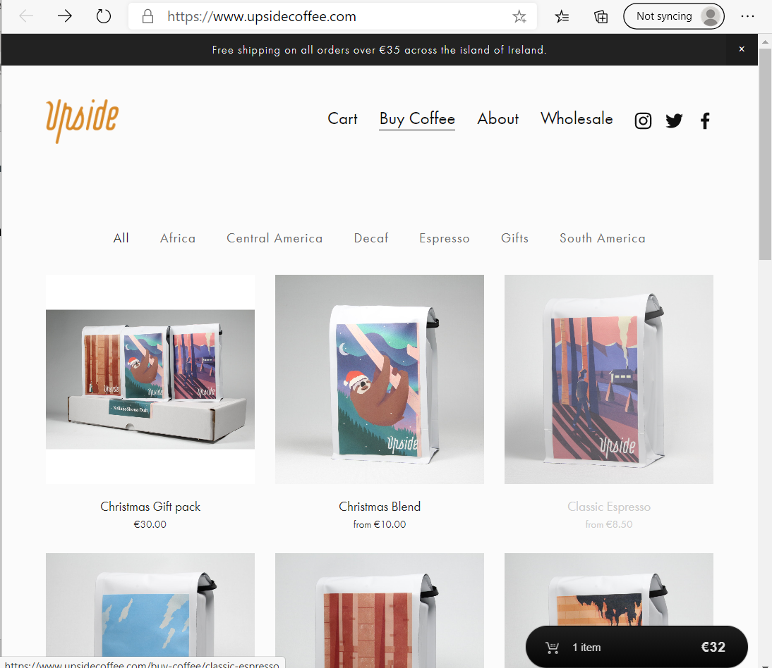

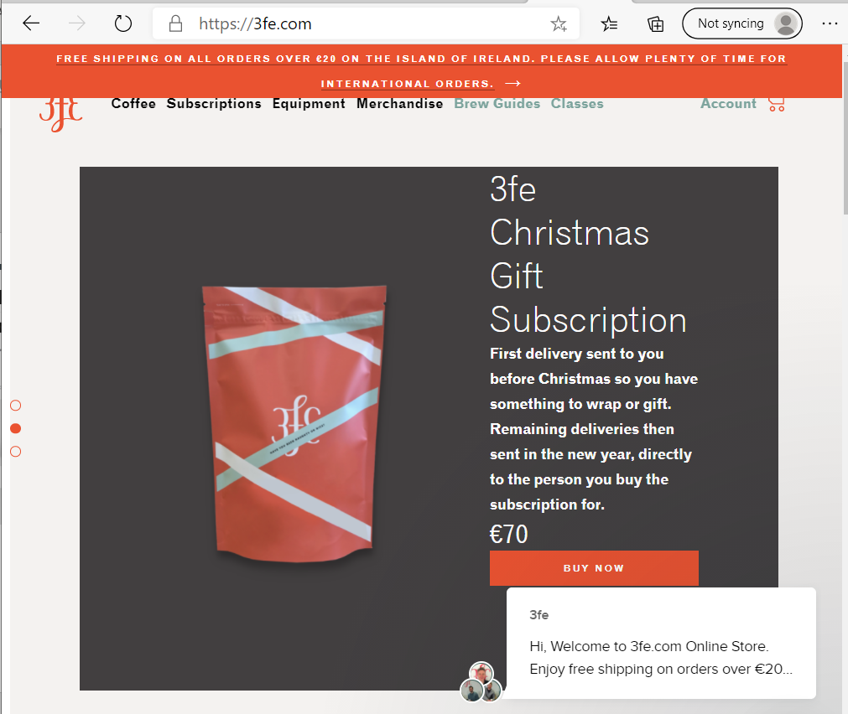

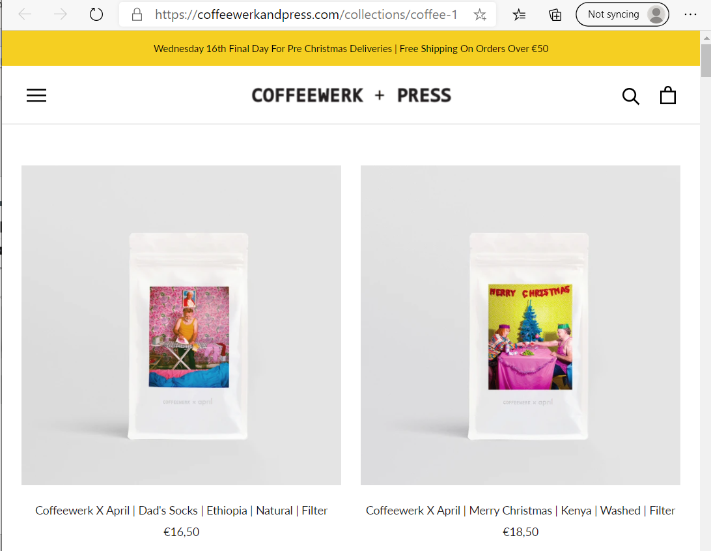

The content addressed the relevant areas:

* + Terms and Conditions
  + About/Our Company
  + Contact us
  + Newsletter/blog
  + Subscribe
  + Privacy Policy

We really liked the beauty of these sites – crisp, & clean. This is the high end of the market – which is reflected in the beautiful images of the products on sale. The detailed brew guides and newletter/blog was an added benefit for true coffee lovers. The additional merchanising provided an added branding opportunity and distingushes their products and the owners of their products!

Perhaps the 3 sites purposely did not push their message in their landing sites – it is subtle. However, it was not always apparent what is on offer with the first look at the home page. They did not use a sidebar on the left to indicate what was on offer. Product space is used to show a single line of product on the home page (on large screens). This makes for a beautiful screen, but, perhaps by using the sidebar you can push more product into the home page. Down the line this could be changed if marketing feedback indicates that a more minimalise design resonates with our target audience/customer base.

We liked:

* + Use of blog/newletter to keep their users informed
  + Use of merchandising for additional branding
  + Sale of high end coffee products and equipement
  + Clean lines
  + No brash animation/video
  + Site content had a meaning – minimalist and informative
  + Very clear target audience
  + They are purposely only showing 1 line of product on the initial home screen (for bigger screens). This adds to the asthetics.

Biggest challenges:

* + To be able to gather high quality image content that reflects the high standards of the target audience.

What was missing:

* + FAQ
  + Site map

General market research shows a concerted market push towards subscription services - quality coffee to the door for a monthly fee. *Pret a Manger* has recently launched a coffee subscription service in the UK. (See reference below). 2020 has brought lock downs and remote working and this in turn has brought an upturn in traditional “barista experience” being moved to the home office. A drive to replace the office coffee pot or water cooler social moment with an online social exchange provides an opportunity to push relevant content to our customers and to provide them with an opportunity to take part. Providing a twitter and facebook presence would be optimal as well as a blog.

Statista figure for the UK reports the home at 76% for the location where they usually drip drip coffee and 24% at work, at the office. (See reference below).

#### Top keywords used by the 3 competitors:

Using Google Ad and the google tools for keyword research the following top keywords were identified:

* + Buy coffee
  + Barista coffees
  + Best coffee roasters
  + Buy online coffee
  + Coffee roasters
  + The best coffee roasters
  + Wholesale coffee equipment

See the section below on google tools for more information.

### Markey research – Survey & Interview

We performed a survey based on 3 initial personas:

* + Regular Joe Soap
  + Coffee Snob
  + Wholesale customer

The following is a summary of the survey results:

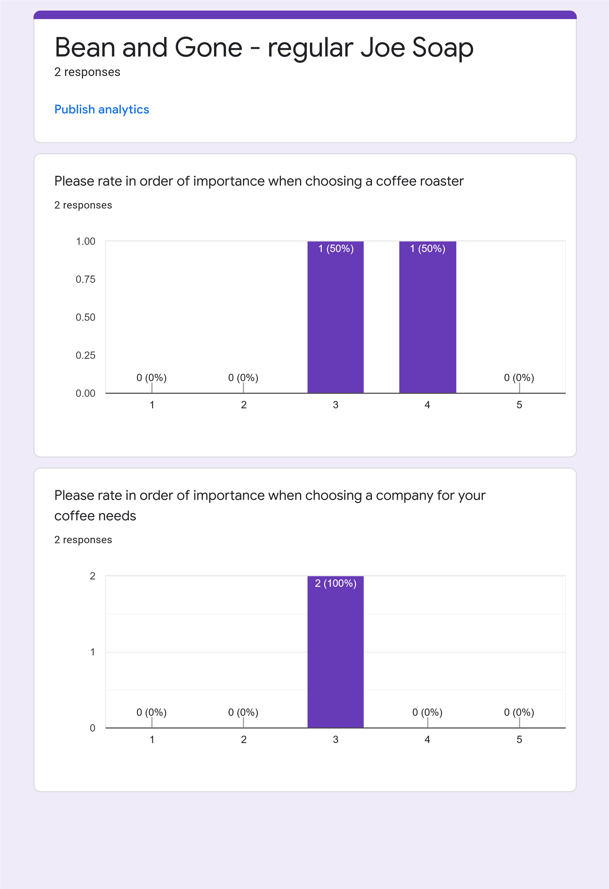

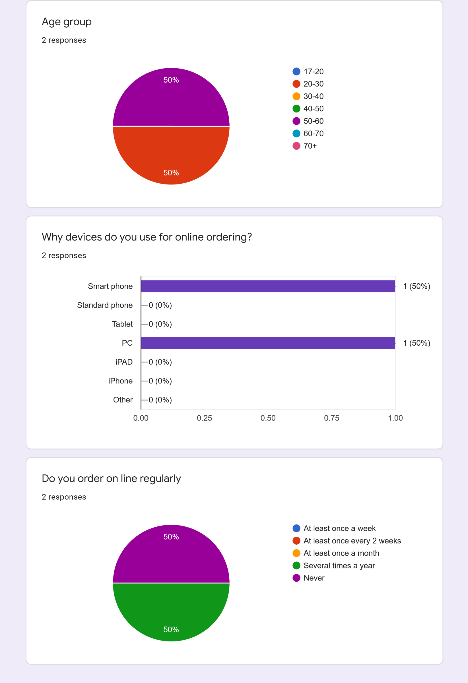

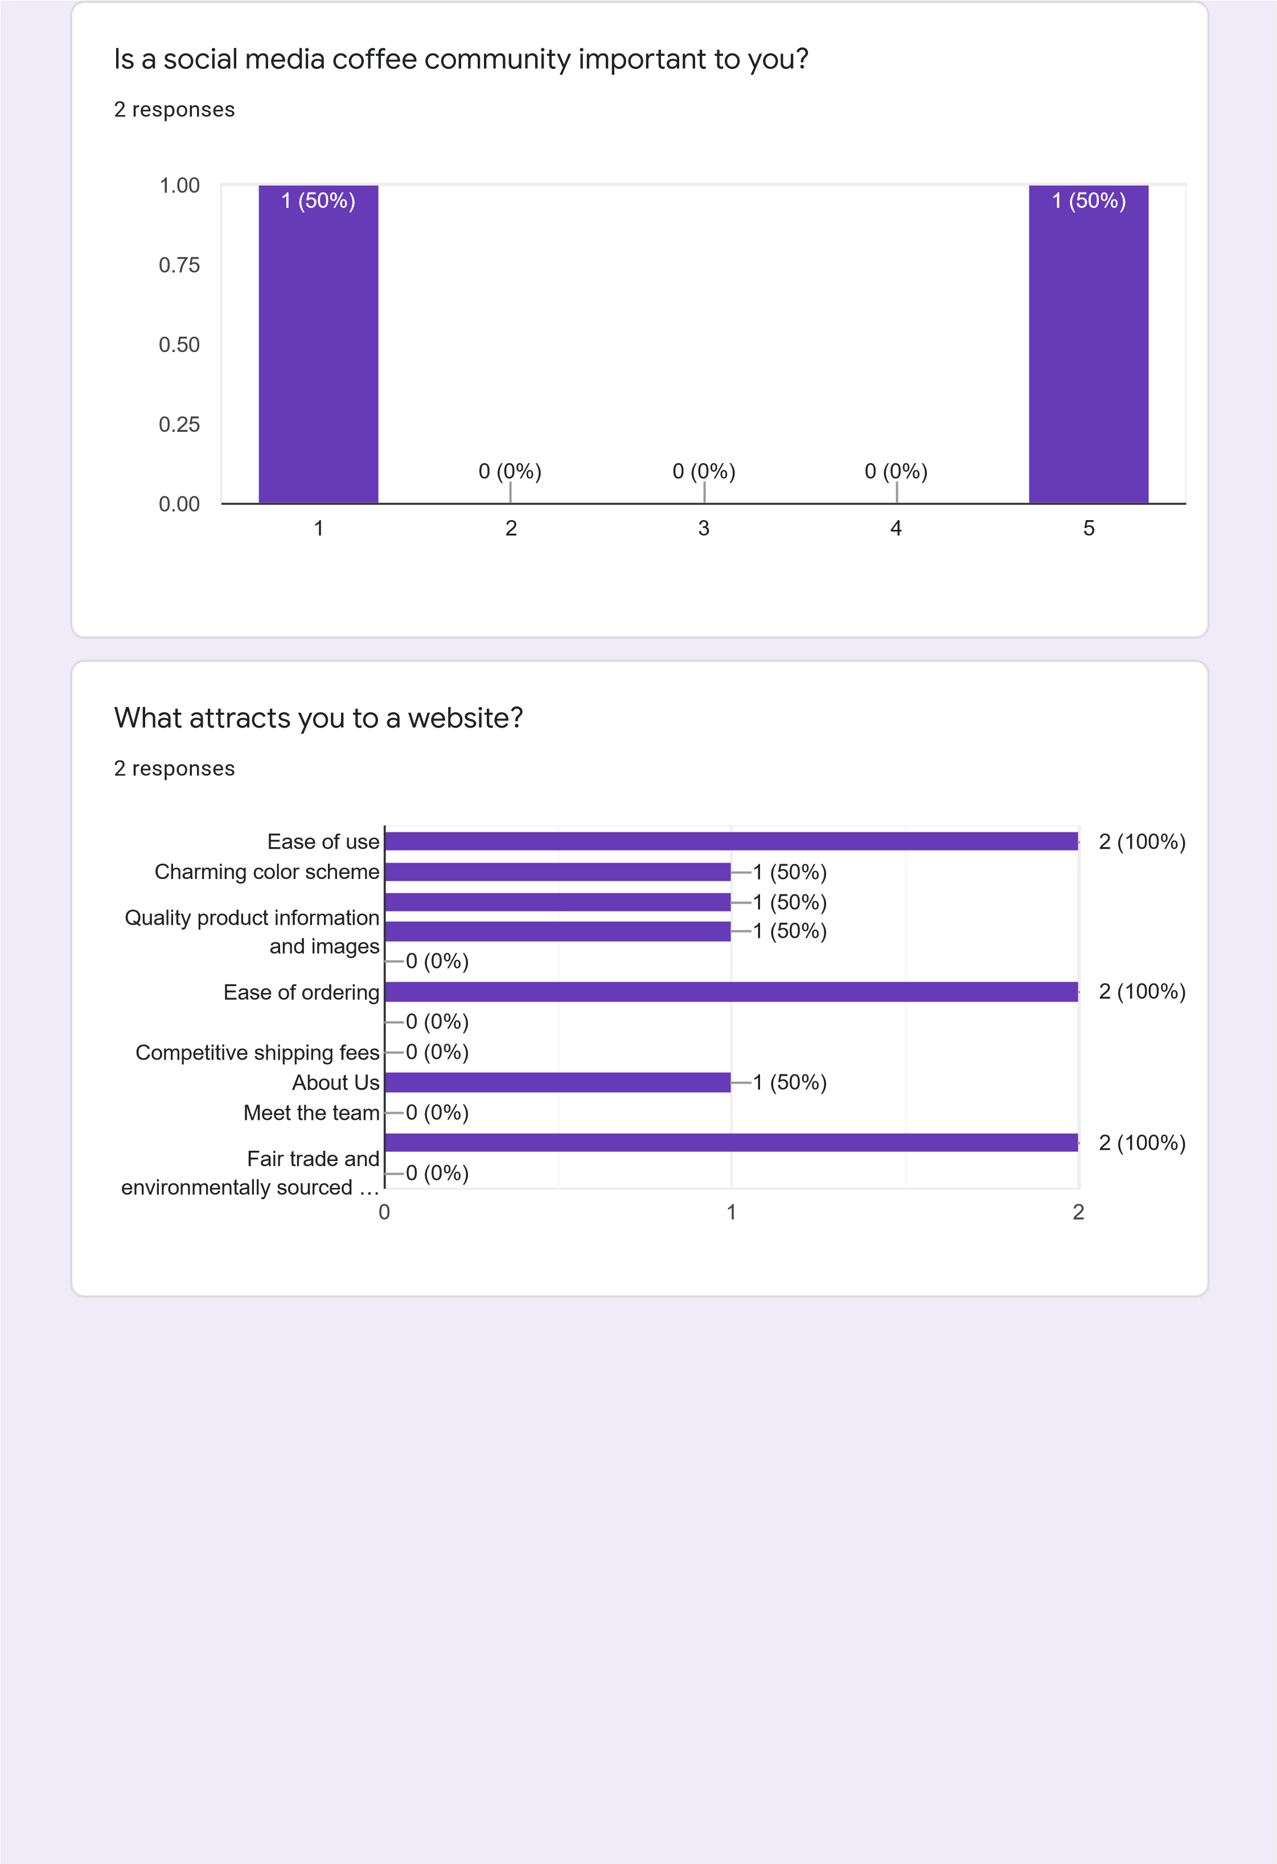

Which colour would your prefer to see in a webpage?

responses

2

Do you prefer dark mode of light mode?

2

responses

If you subscribe, how often would you like a delivery?

responses

2

1

2

3

4

5

0.00

0.25

0.50

0.75

1.00

)

(0%

0

1

(50%

)

(0%

)

0

0

(0%

)

1

(50%

)

Dark mode (gray/black)

Light mode (white/light gray)

100

%

Every week

Every 2 weeks

Once a month

Once a quarter

50

%

50

%

|  |
| --- |
| This content is neither created nor endorsed by Google. [Report Abuse](https://docs.google.com/forms/d/1AVBIFKs7RzEq80WR76L-K4-vKEKKqCXVh9pusoK2mwo/reportabuse) - [Terms of Service](https://policies.google.com/terms) - [Privacy Policy](https://policies.google.com/privacy)  [Forms](https://www.google.com/forms/about/?utm_source=product&utm_medium=forms_logo&utm_campaign=forms) |

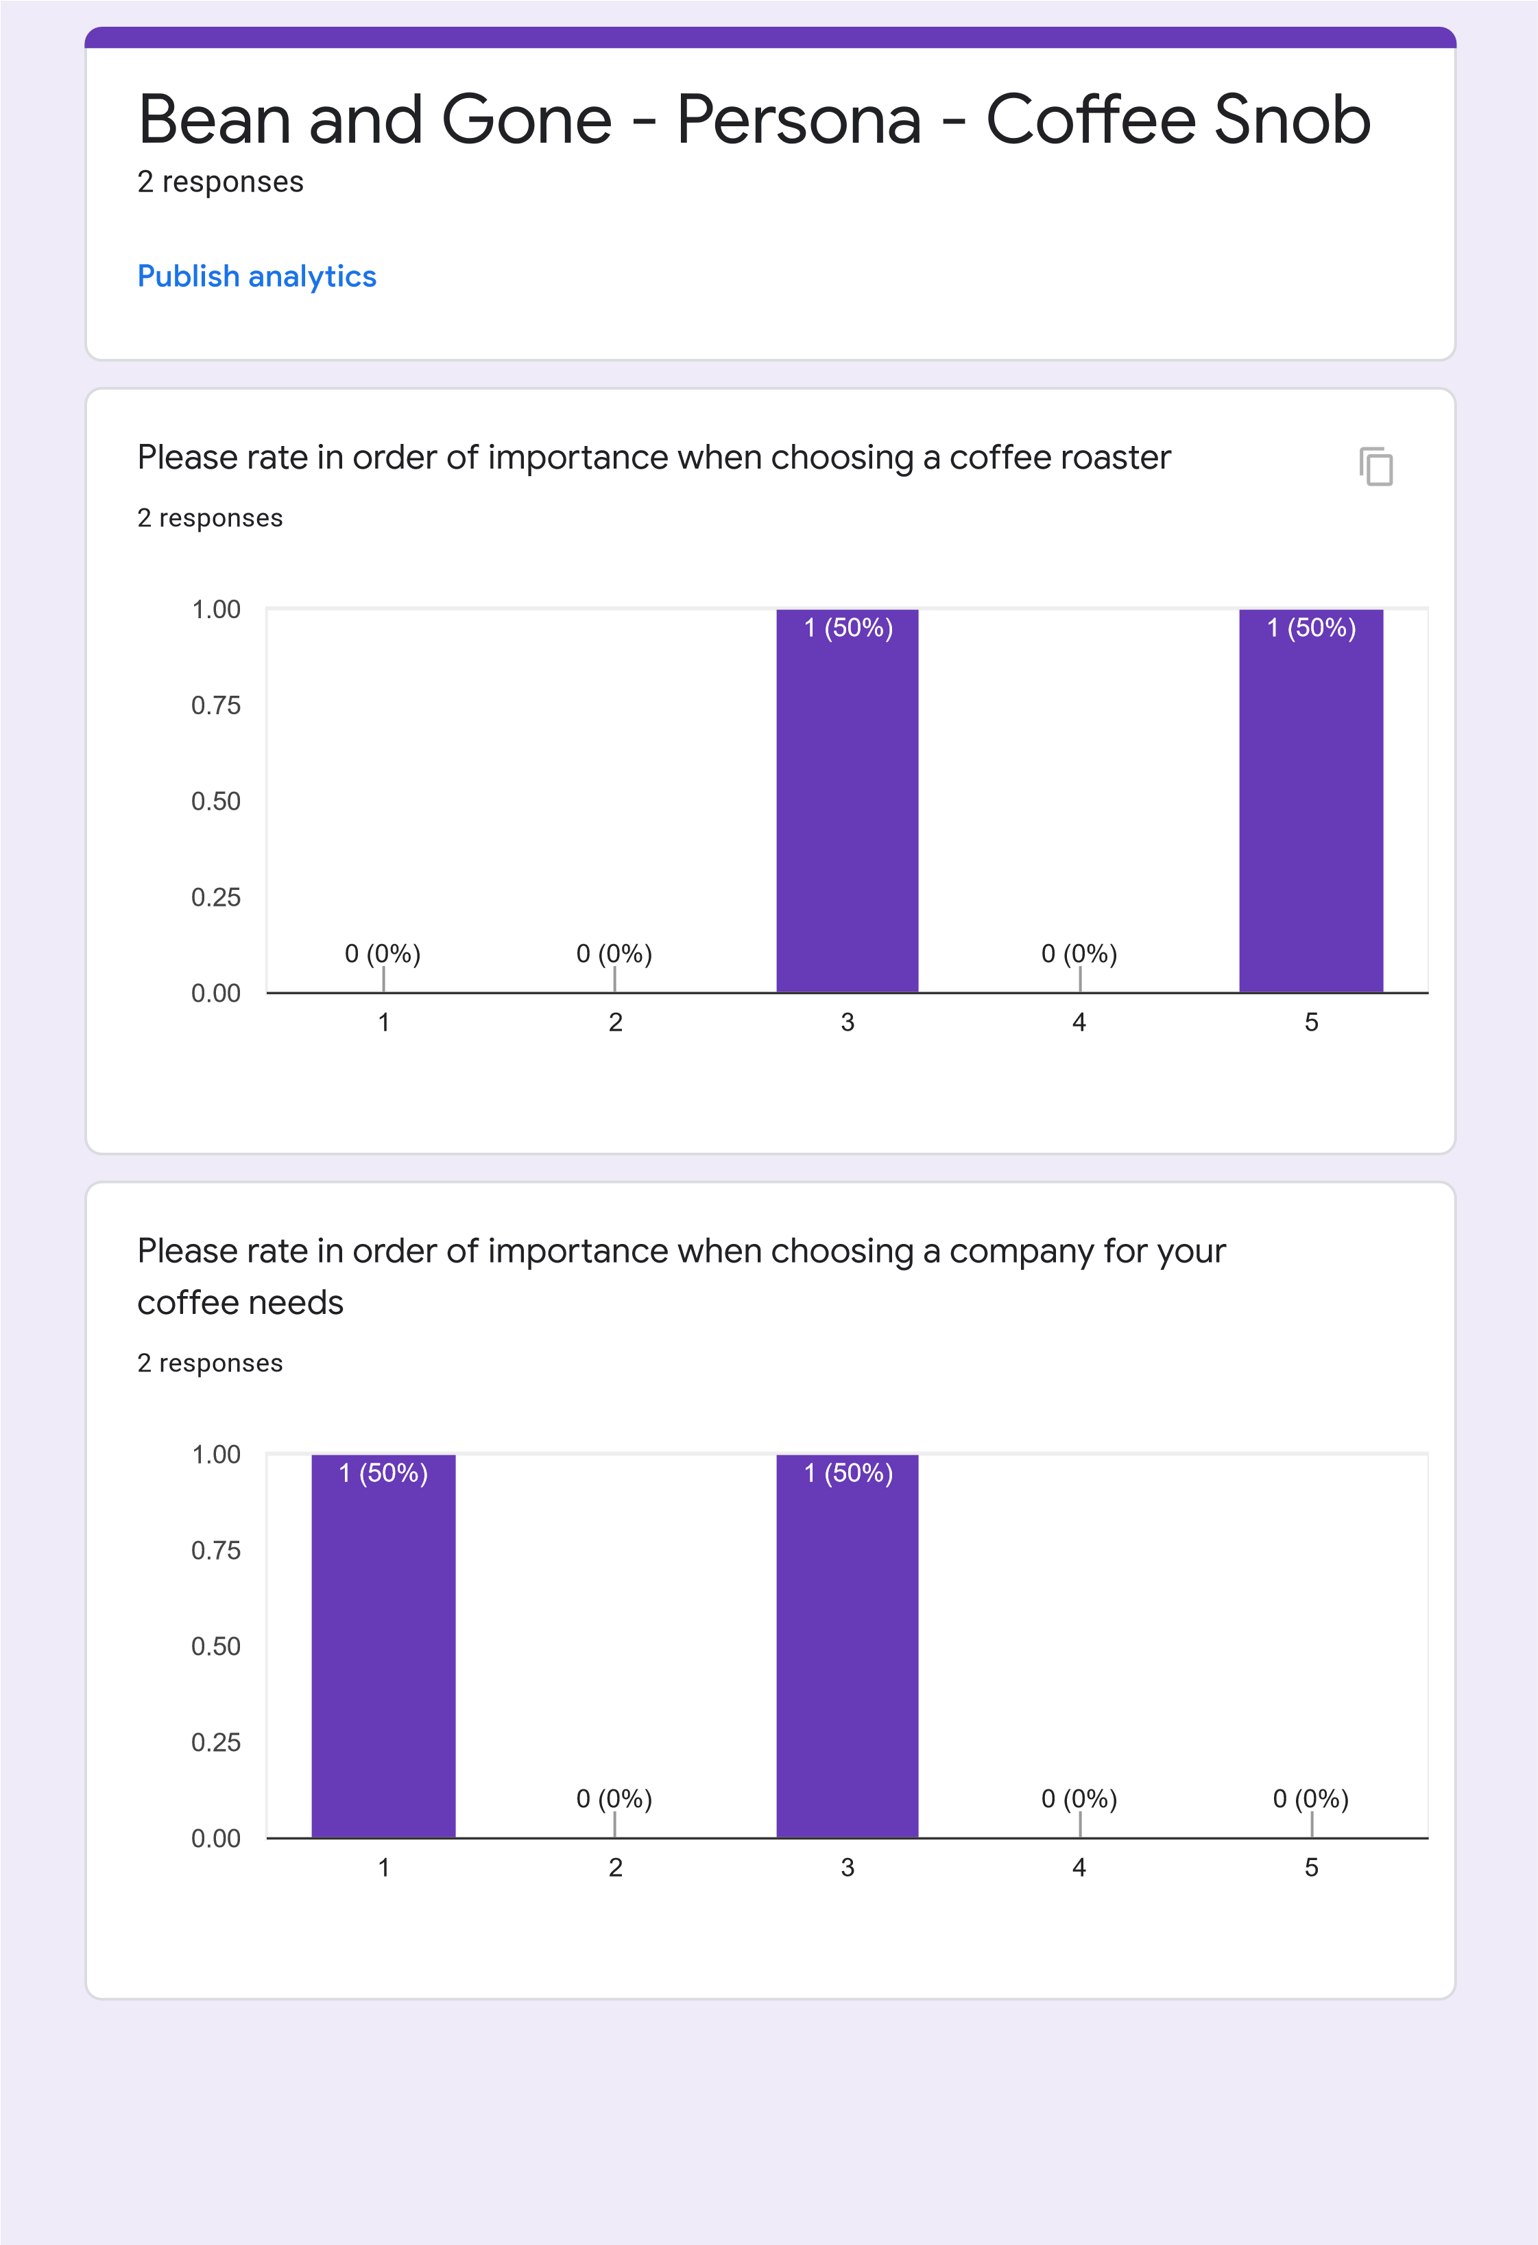

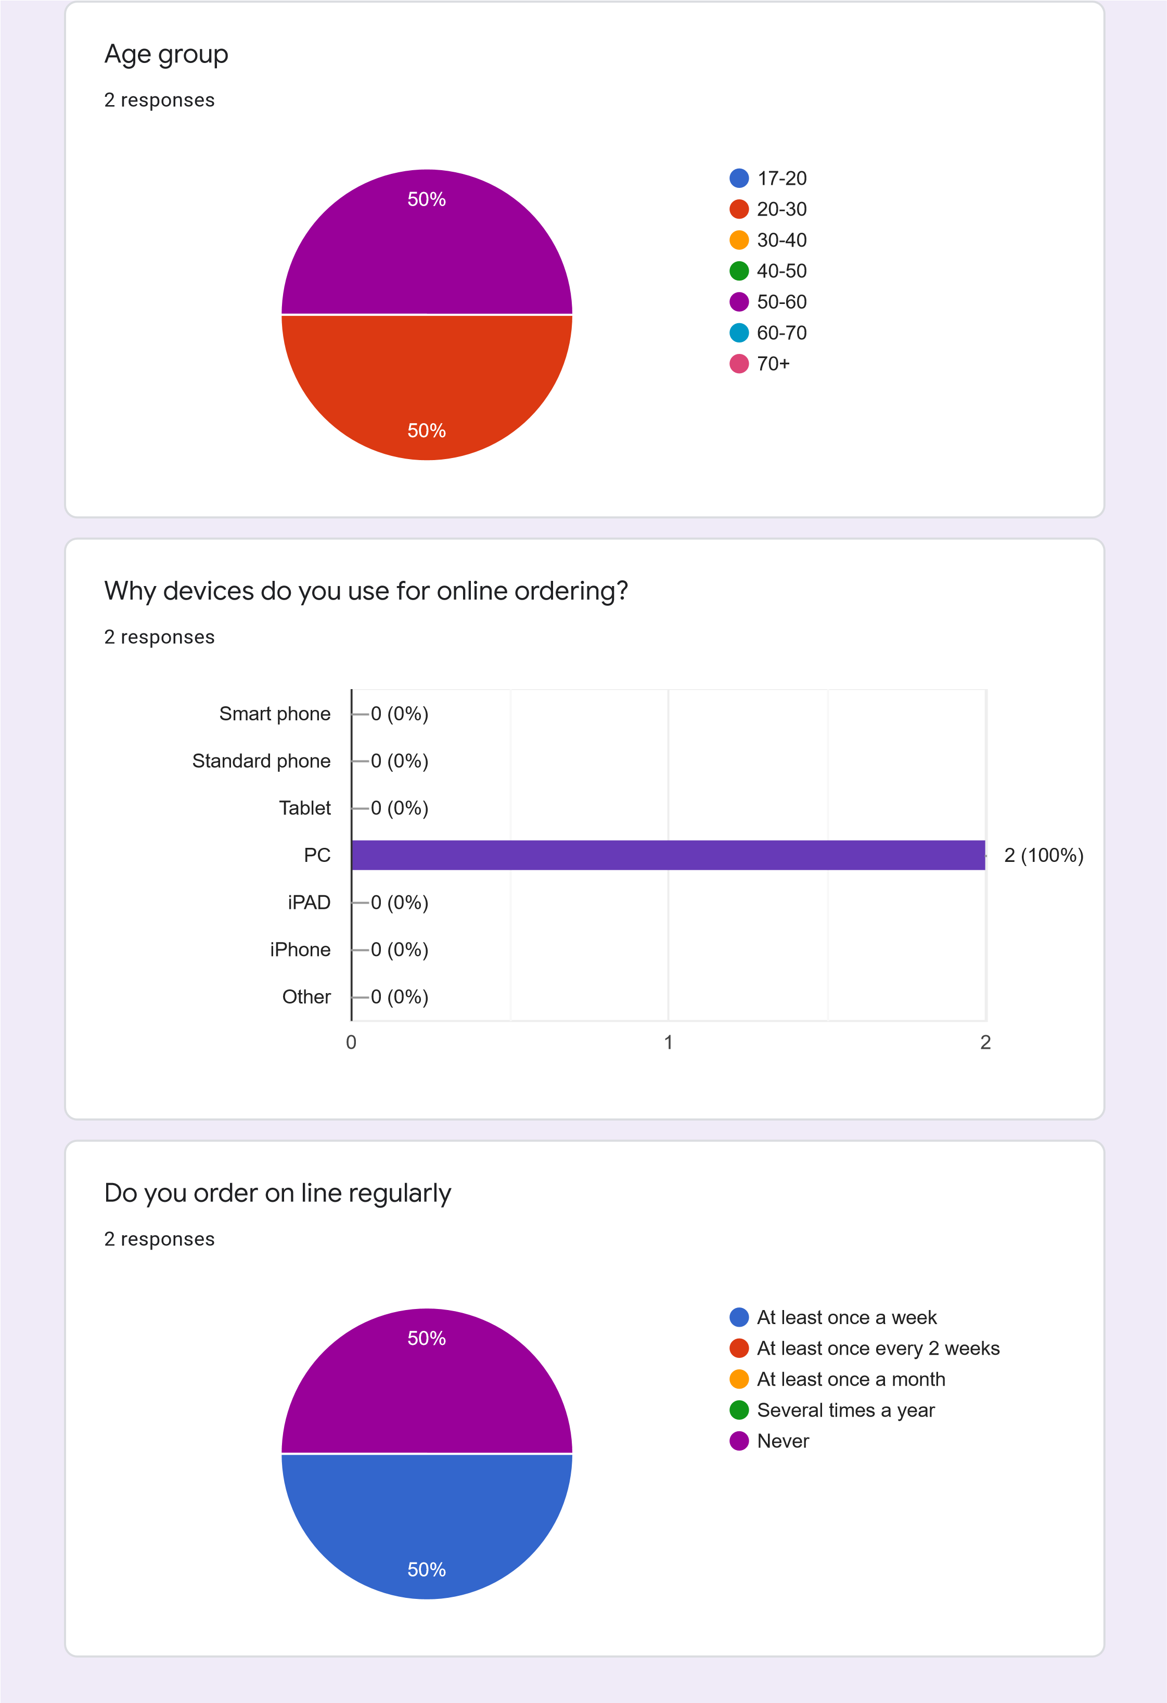

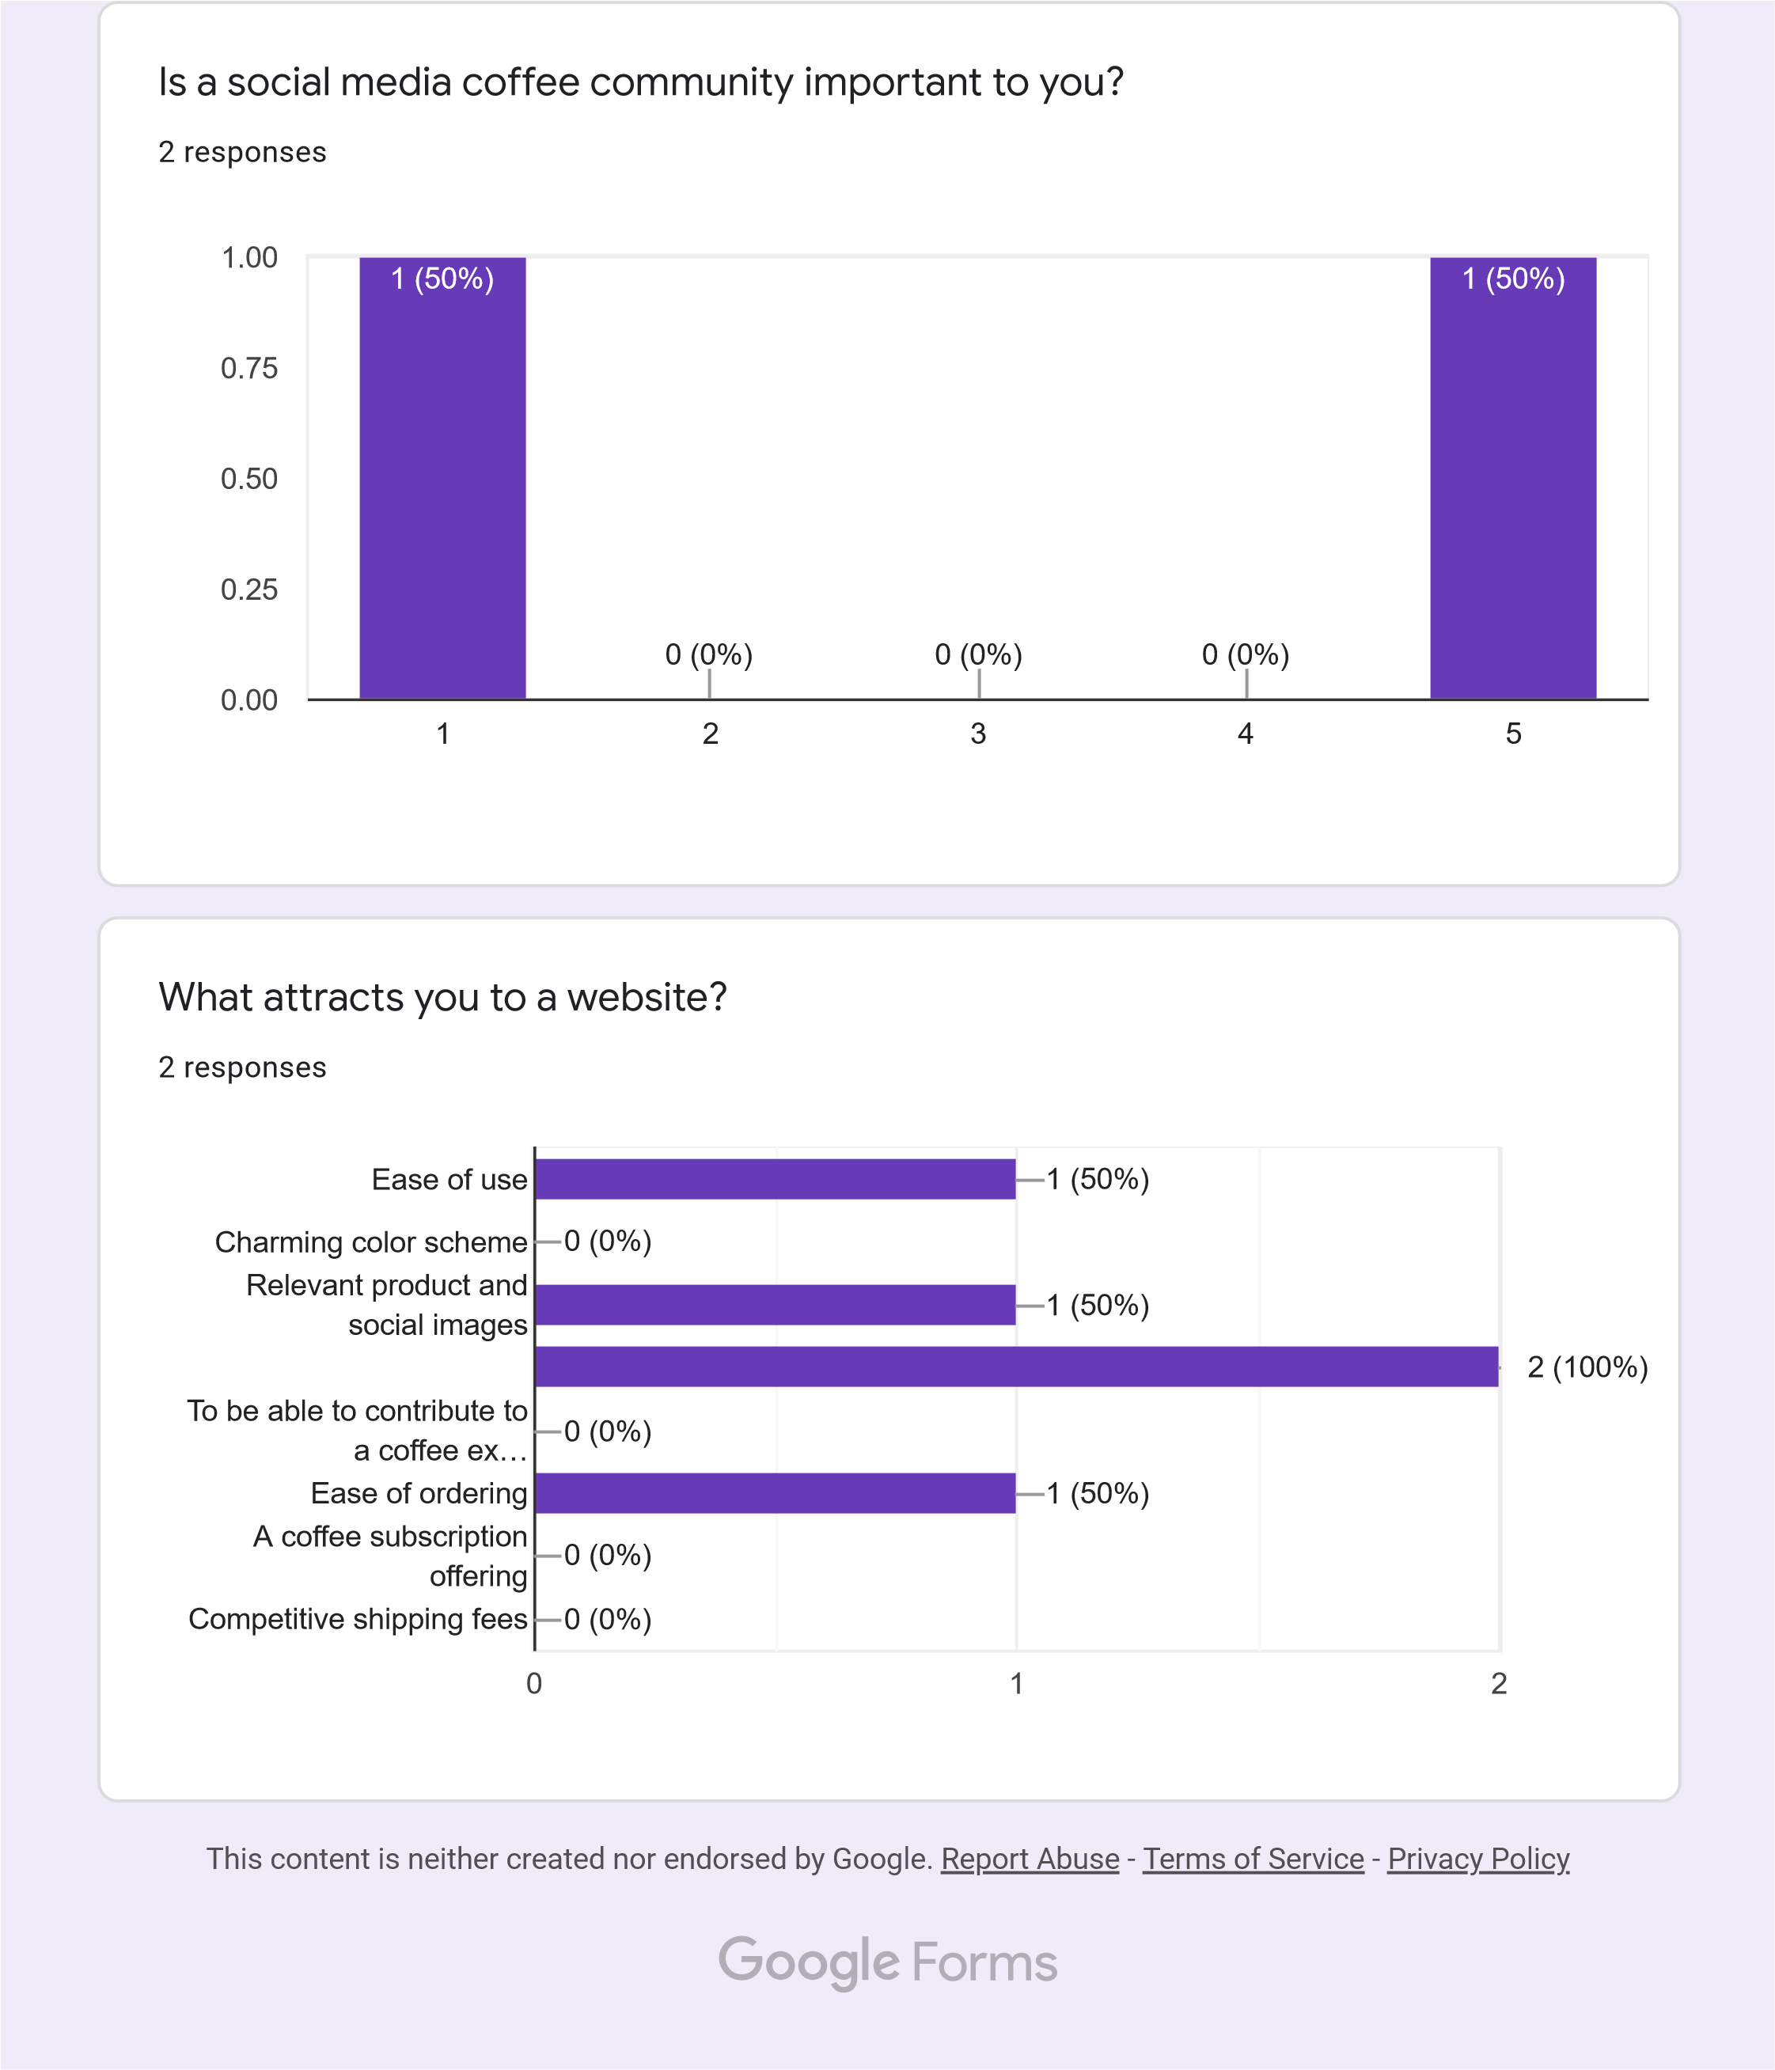

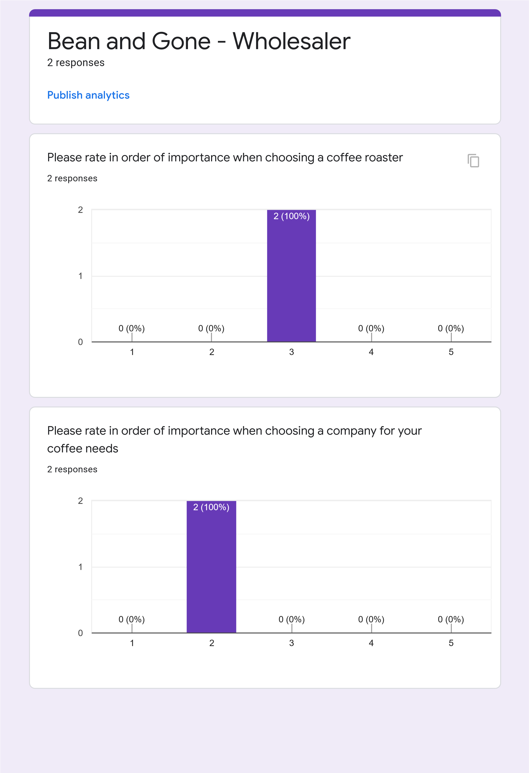

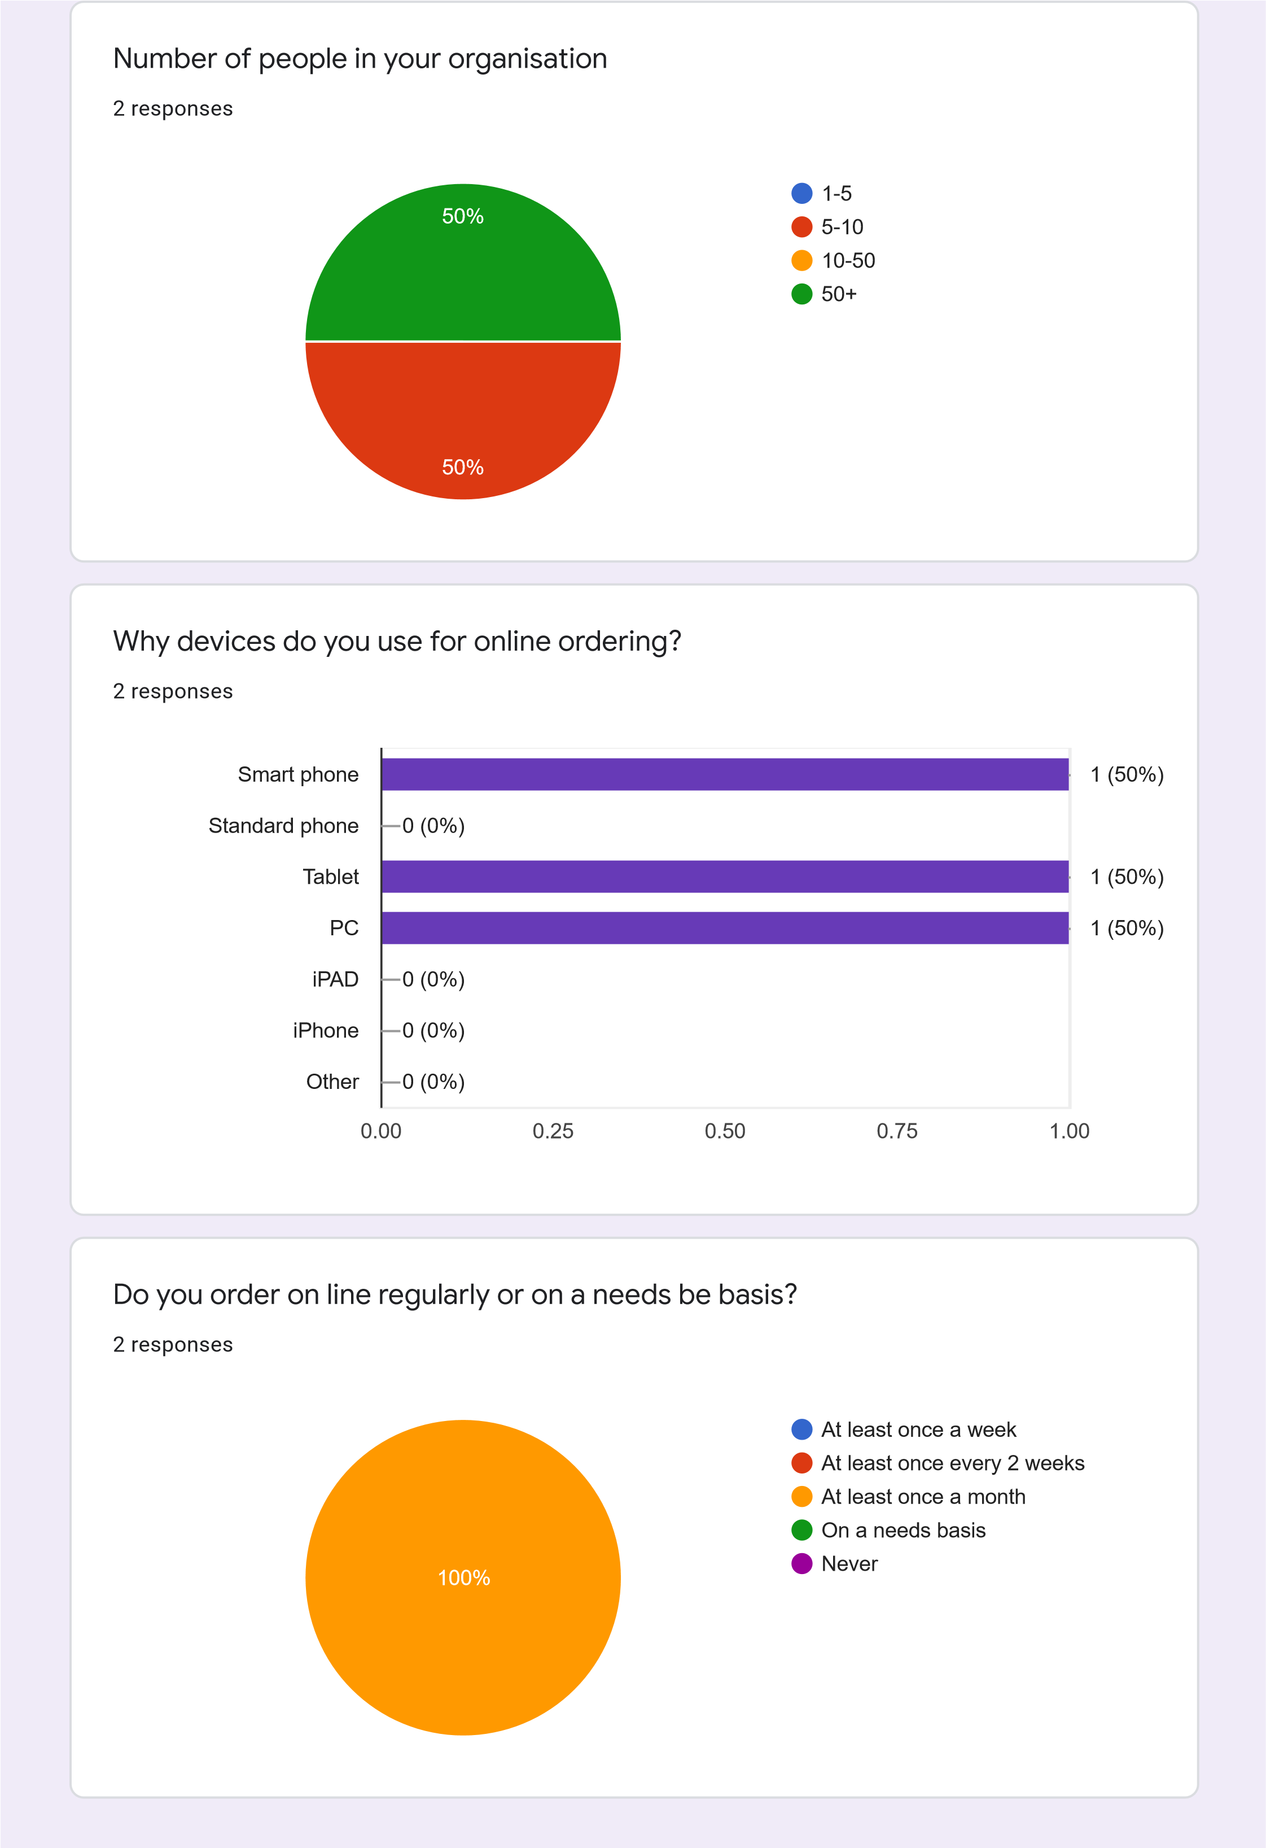

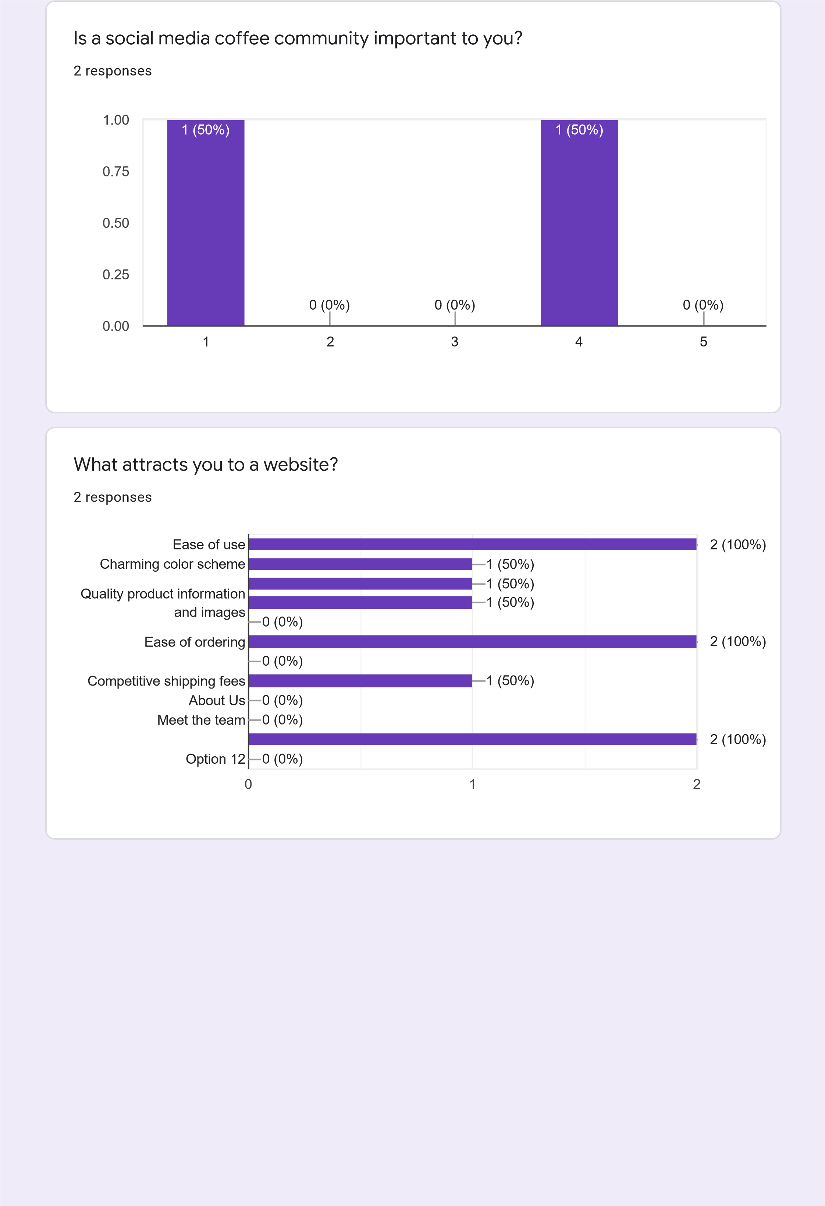

Which colour would your prefer to see in a webpage?

responses

2

Do you prefer dark mode of light mode?

responses

2

1

2

3

4

5

0.00

0.25

0.50

0.75

1.00

)

(0%

0

(50%

)

1

)

(0%

0

)

(0%

0

)

(50%

1

Dark mode (gray/black)

Light mode (white/light gray)

100

%

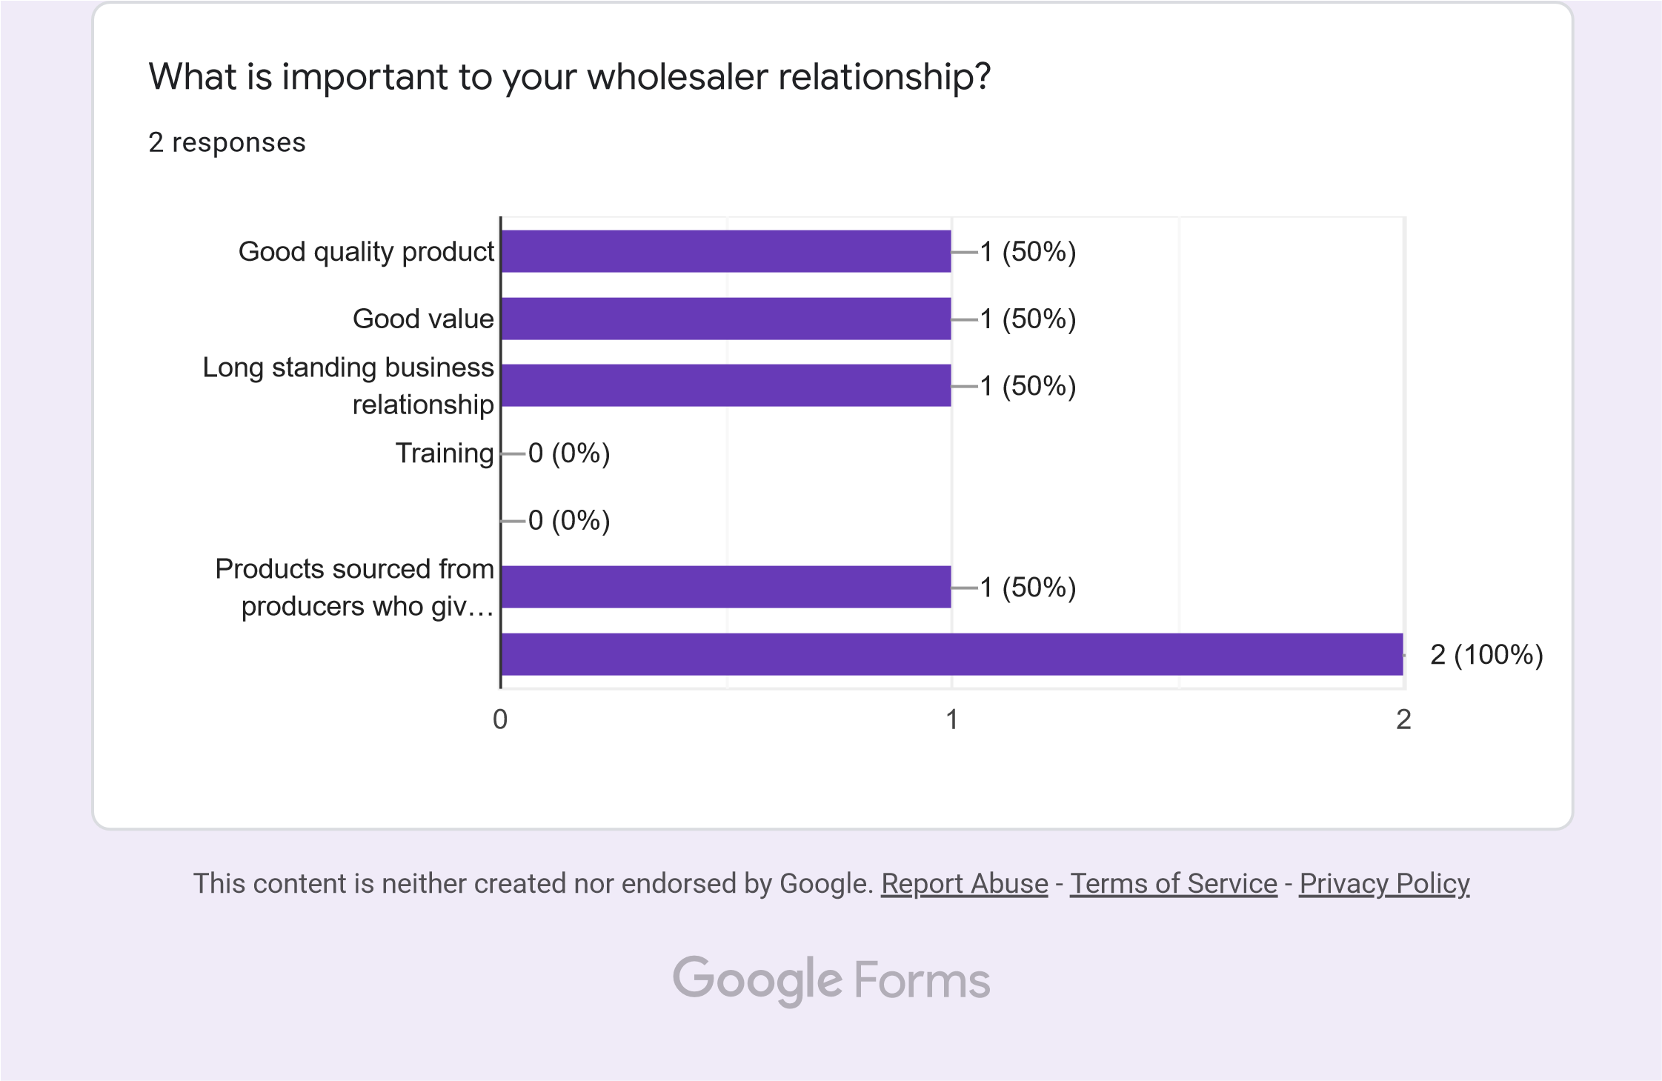

### Interview with Team J members

We performed an extended interview with Team J memebers and covered 2 topics:

* + Feedback on the survey forms – we asked them to fill out the forms during the interview and to talk us through their answers and provide comments and ideas
  + Feedback on the wireframes – Rob walked them through the wireframes and a lot of feedback and ideas were illicited.

We will briefly cover survey form feedback here from the interview here, wireframe feedback is covered below.

A lot of feedback was provided on the survey questions themselves – this was very useful as it meant that we needed to address a few things in our website:

* + Provide a definition of roast and roaster? Don’t assume knowledge.
  + Age profiling is not always a good idea.
  + Ordering online was split between PC/Smart Phone/Tablet
  + Some customers have never ordered online – decide to go after or just ignore this market section?
  + Light mode was 100% preference. Which left us in a bit of a quandry as we both had arrived at a darker left hand side nav bar. But we decided to use light/white for the main body of each page.
  + Orange/Green color – 50/50 split. We had initially looked at a 3rd major color block.
  + Ease of use, speed of process and quality of experience was a must for all surveyed individuals.
  + A preference for local roasters was expressed – instead of a large range of international products.
  + All personas interviewed/surveyed expressed as a mimimum information on the sourcing of all products – FairTrade and environmentally sourced product was extremely important. All our customers were very aware and tuned into this requirement. We must provide this type of product and importantly share this information with the customers. If this was not a student website we would ideally provide FairTrade branding.
  + The ideal time frames for subscription coffee service were once a month and every quarter.
  + Our coffee snob personas expressed a preference for compostible cups and keep cups – these must be added to our coffee merchandise offering.
  + All personas were conservative in choice of coffee grade/strength. We feel that there is a market opportunity for a subscription service that offers the customer an opportunity to try out different coffees that they would normally not go for.
  + The wholesaler was most interested in a long term business relationship – which is good news.

### Audience Analysis & Persona

Rob developed detailed personas for the typical customers of Bean & Gone. We identified a nice opportunity to provide a subscriber service for coffee. What we saw in the real world with the Pret A Manger was backed up by the interviews with Team K – there was definitely an opportunity for subscribe coffee service.

### Personas

The following are the 3 relevant personas:

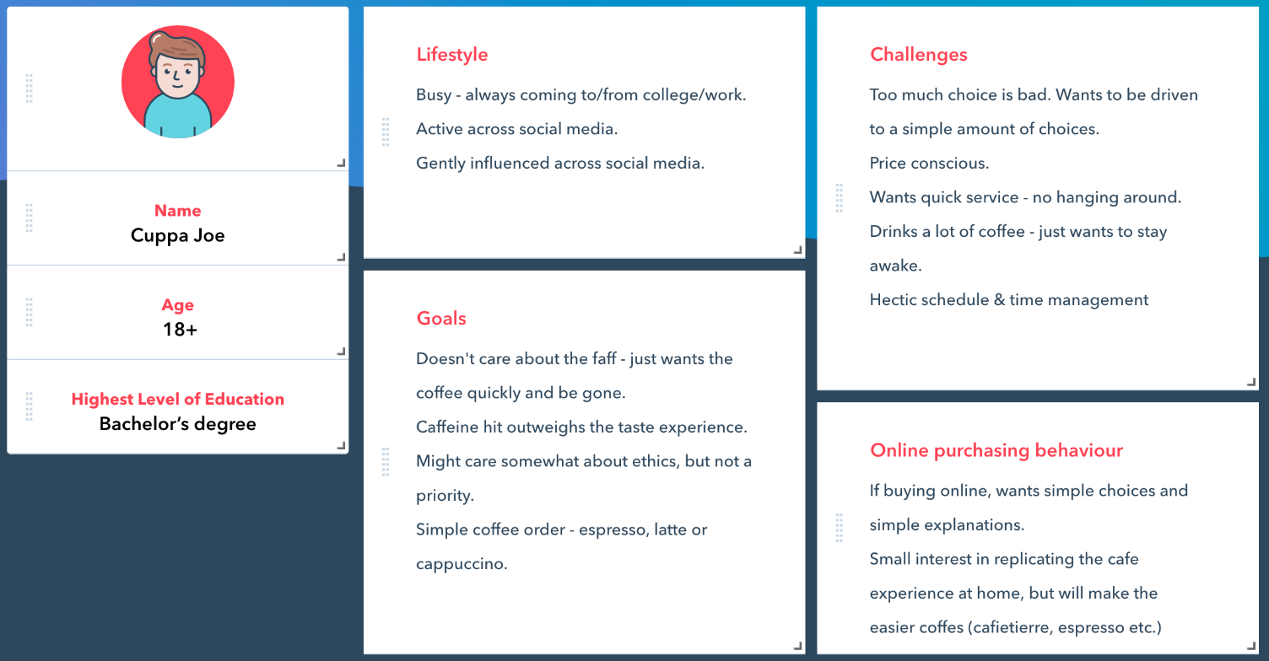

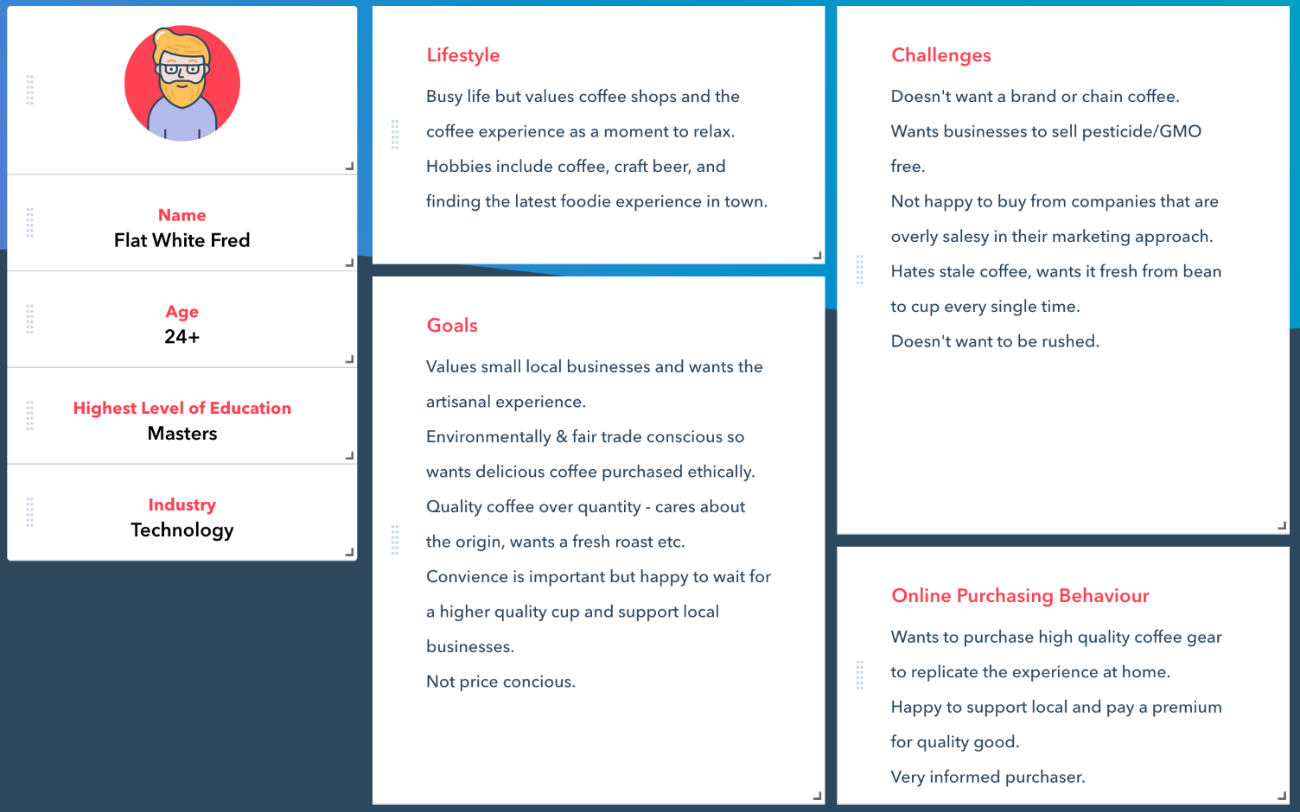

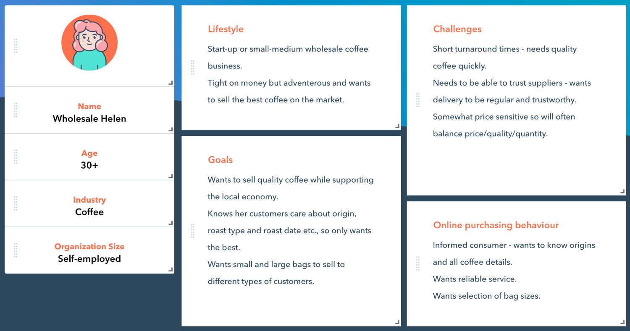

## Requirements & Technical Approach

** This section should outline what requirements that project might have and how you initially plan to approach project development, taking these requirements into consideration. You should also address other design aspects such as looking at suitable design hueristics/standards that you feel will contribute to your project. **

#### Basic website requirement:

We agreed on a and purpose.

We went through several titles for the web site. We hit on Bean & Gone as a good option. We did 2 deployments (1 for each CSS file) – one with Bean & Gone and the other with Bean & Gone Coffee. It should be interesting from an SEO viewpoint to see if the title with Coffee in it gets higher hits or not!

We chose github’s gitpages for hosting because of for its ease of use. The website hostnames were:

Sinead’s CSS file deployed version

[Bean & Gone Coffee (sinead-dotcom.github.io)](https://sinead-dotcom.github.io/beanAndGoneCoffee/index.html)

Rob’s CSS file deployed version

[Home Bean & Gone (sinead-dotcom.github.io)](https://sinead-dotcom.github.io/beanAndGone/)

Our site uses HTM5, CSS, JQuery and JavaScript as the underlying technologies.

The purpose of our website:

* Promote our coffee products, equipment, and merchandise.
* To sell the product online (as PHP or server -side implementation is not part of this brief, empty tags left for future development.
* Provide a social platform for our customers to have that “coffee-maker moment” in these Covid-19 work at home times.
* Email marketing.
* Hence we have a live email account, twitter account and facebook account.

#### Other website requirements

* Provide a clear site map and flow chart.
  + The side navigation provides a nice overall view of the site options. The footer provides a direct link to FAQ and other secondary pages.
* Use colour & layout to reinforce branding

We liked the colour schemes from the 3 researched websites. Rob decided on a Green contrast colour, Sinead decided on an Orange contrast colour. We kept the look crisp and clean.

* Minimise content
  + The pages were not overloaded with content. The FAQ page provided further information for those interested.
* Tone of our site
  + The tone is a professional tone with a welcoming note. We are enthusiastic about the product and our commitment to sustainability and the environment.
* Content keywords to include:

Shop coffee

Buy coffee

Barista coffees

Buy online coffee

Best coffee roasters

Coffee roasters

Wholesale coffee

Coffee blends

* Audience profile:
  + See the personas above.
* No pop up messages or extra advertising – our customers do not like this.
* Simple, understated design
* Easy navigation especially on a mobile device
* We have worked on optimisation so that our website is easy to find.
* Use of citrus colours to bring attention to actions buttons? Investigate whether it takes from the understanded tone. Nice crisp, square edges and look.
* Unique offering: social coffee moments
* Responsive across all devices especially mobile and multiple browsers
* Font choice: legible and crisp
* Registration required to buy online – give them a discount for doing this?
* Footer design – provide value for the mobile experience especially.
* Provided privacy policy information. As there is no PHP involved in this brief – there are no security concerns.
* Must have pages:
  + Home/Index page
  + About
  + Contact us
  + Coffee Menu
  + Coffee Merchandise
  + Product page
  + FAQ

#### Project approach:

Once the initial planning, interviewing and wireframes, it was apparent that we should initially focus on the coffee menu/coffee merchandising pages. A big aspect of the project was the images and how we can successfully showcase our products. An early choice was to get a prototype for the home/product page up and running as fast as possible. Then we needed to figure out to get the image or product information onto the site.

We basically have 2 types of product items: ones with an image and ones without an image. We decided to prototype some initial product items to get a feel for the image size that we would need to develop across the devices and screen sizes. We wanted to optimise image size for mobile devices. It took several iterations to get a feel for what worked and did not work for the landing page. We also need to judge whether the sidebar was a positive aspect and whether we should show 1 line of product in the initial page on screen or more. The initial prototype threw up a lot of questions and helped to refine the site message/tone. Once the landing page was tuned, we revised the wireframes and web page designs for all other pages.

Initially the prototype involved a mock-up wireframe and that was quickly followed by a template HTML web page. The low-fidelity prototype involved use of both a brand icon and brand name/icon PNG that was minimal but gave a good feel for how the image could add to the tone. As how the product/item was to be displayed a good deal of time looking at several alternatives was spent on low-fidelity product/item options for the home page.

Card sorting was used to order the navigation flow and information content.

Once there was agreement on the main aspects of the product/home page, navigation and flow we moved onto the high fidelity choices.

#### Design aspects:

#### Design Heuristics

Use web safe colours. Colour scheme to work with the coffee image – what works for our competitors is the inclusion of a single citrus colour with black/shite/tan/beige. Ensure good colour contrast by using black/white where appropriate.

It was decided to keep important information above the fold – header, logo, navigation and ½ lines of the main content area. We tested the layout of this design in the low-fidelity prototype.

We presented the **best selling** products on the 1st line in the FOLD. Obviously down the line with data analytics customer products would be presented on this FOLD product line.

We use the product LOGO and icon should be used to return to the home page.

We use theme theme and navigation through the site.

The design works for both mobile and large screens.

We used the AIDA approach to measure the effectiveness of advertising – Attention, Interest, Desire and Action.

Artistic impact – this site must shout simple, stylish and high end.

Use images to sell the product. Minimise text, maximise white space.

We demonstrated navigation using multiple techniques:

* + Javascript button on mobile device for sidebar options
  + Navigation Sidebar menu using hyperlinks to move to pages
  + Hyperlinks in footer to go to lesser used pages like FAQ.
  + Clickable Icons like the brand to go to Home.

#### Structure:

Form of web site and it’s navigation.

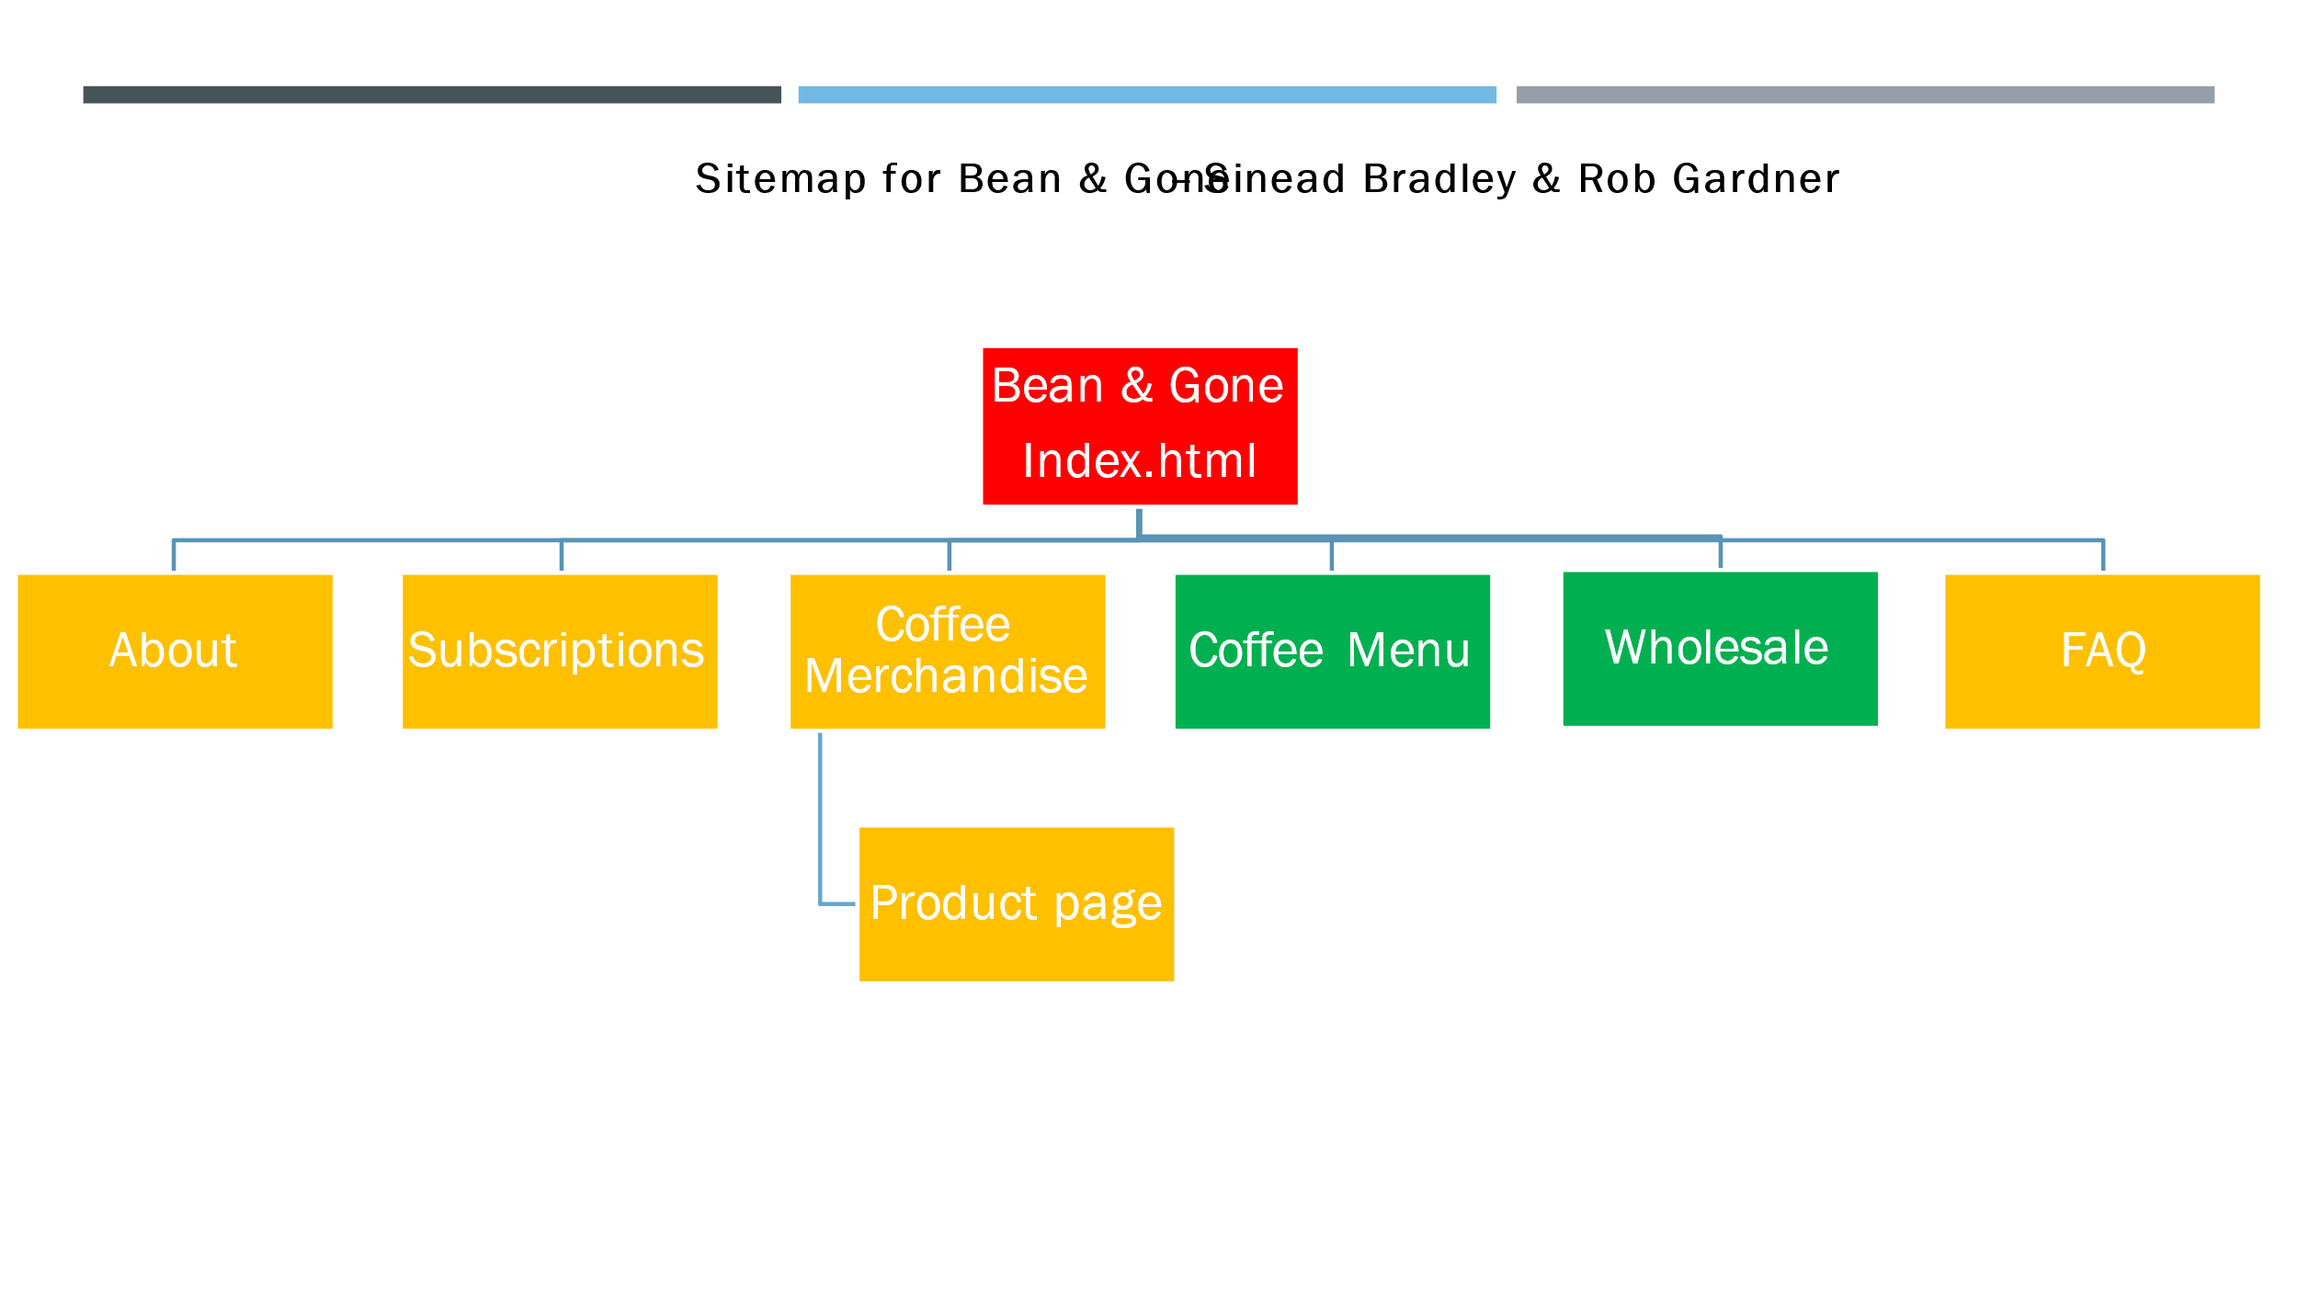

The following shows the side navigation option for larger devices/screens:

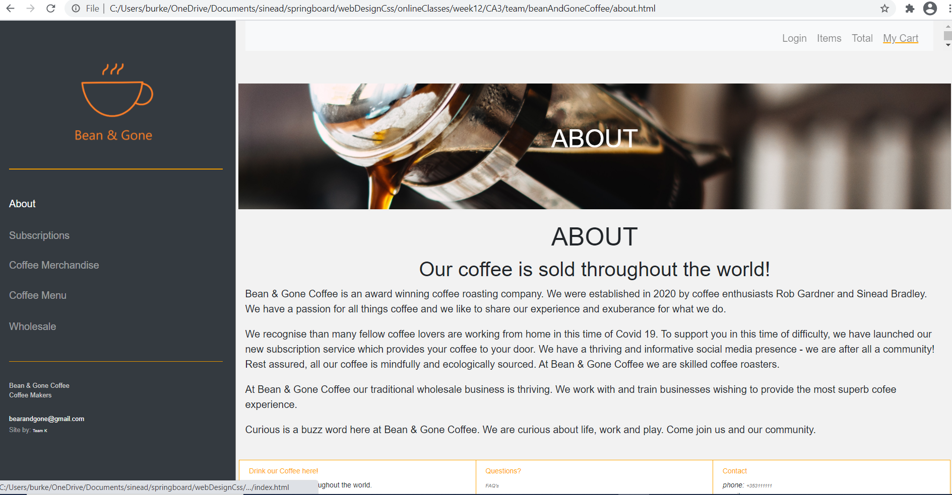

Note that the footer provides access to lesser use pages – for example the FAQ page.

Below is how the site looks on a mobile device or smaller screen. Note the pull down hamburger that allows access to the menu.

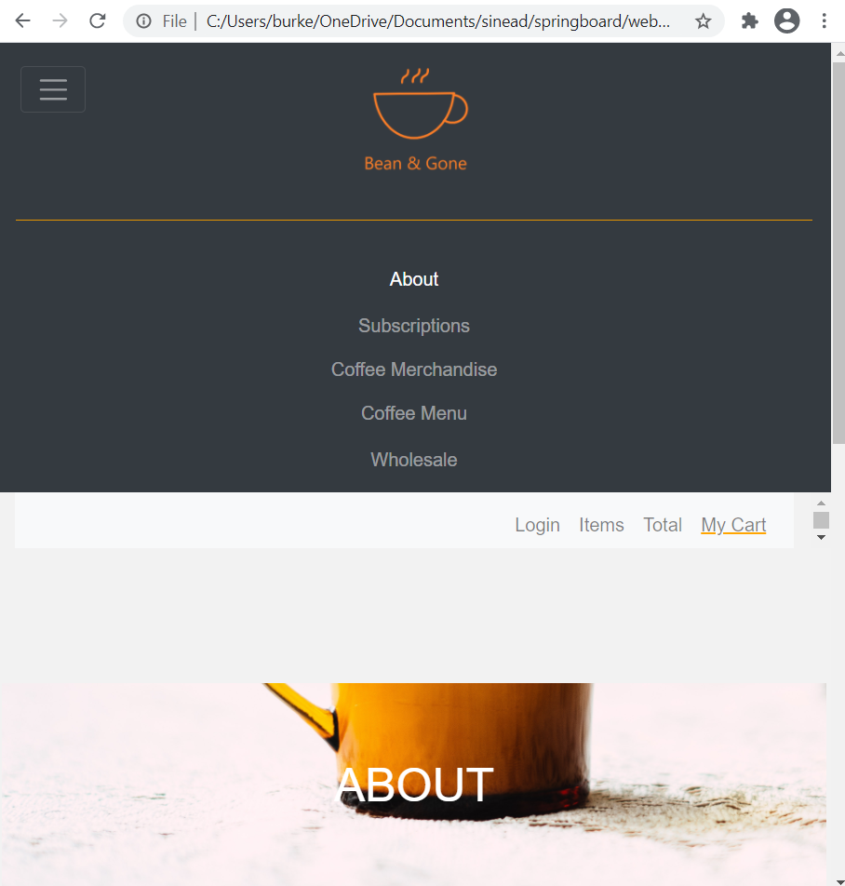

#### Design Standards

* Mandel’s 3 Golden Rules for usability
* Accessibility
* Google & Apple web design standards

## Sitemap & Wireframe

** Include sitemap and wireframe for your website here, including brief explanations of each as needed, etc. **



#### Content:

#### Layout:

#### Interview feedback on Wireframes:

# Development

** This section should outline how you went about developing your webpage, i.e. HTML, CSS, JavaScript. This should include information on requirements and standards implementation, code development and technical details, such as errors or development issues and how you fixed these.

**Please note:** Make sure to include an explanation in this report (**as well as** comments in the HTML files) of any & all code that was taken from the web, or you will **not** receive marks for this third-party code. **

## Design Standards used :

#### Bootstrap framework:

A decision was made to use Bootstrap as a framework. We decided on v4.5 . It was important to use examples from the documentation that were relevant to the v4.5 implementation of bootstrap. Ideas for the layout and implementation of our site came from the excellent examples on getbootstrap.com. We used the **code ideas form the Carousel, Navbar, Dashboard, Fixed Top Navbar, Grid system, Checkout and Bootstrap pages themselves.** We also used the excellent online videos by Sam Cogan on getting started with Bootstrap. For a full list please see the appendix. For example, the Consent popup uses the Bootstrap modal design, the FAQ page uses the bootstrap accordion design.

#### HTML5 & CSS3

We used the HTML5shiv to assist with unrecognised HTML5 elements.

Validation as performed using the following tools: <https://validator.w3org> and http:/jigsaw.w3org/css-validator/

#### Copyright & Creative Commons

Was adhered to. Sources of images include:

* Pixabay

## Validation & Errors

** This section should look at validation of the website (HTML & CSS), were you able to validate the website, were there any errors and if so, how did you go about fixing them.

**Please make sure to include a screenshot(s) of your validation reports here \*\***

#### Some early validation efforts:

## 

Errors 1 &2 were straight forward, I needed to add an “alt” attribute to provide a description in case the image file was unavailable/not found.

Error 3: I had an extra </div> which was unmatched by a <div>, simple deletion required.

Error 4: Cannot use double dash in the middle of a comment! Substitute single dash.

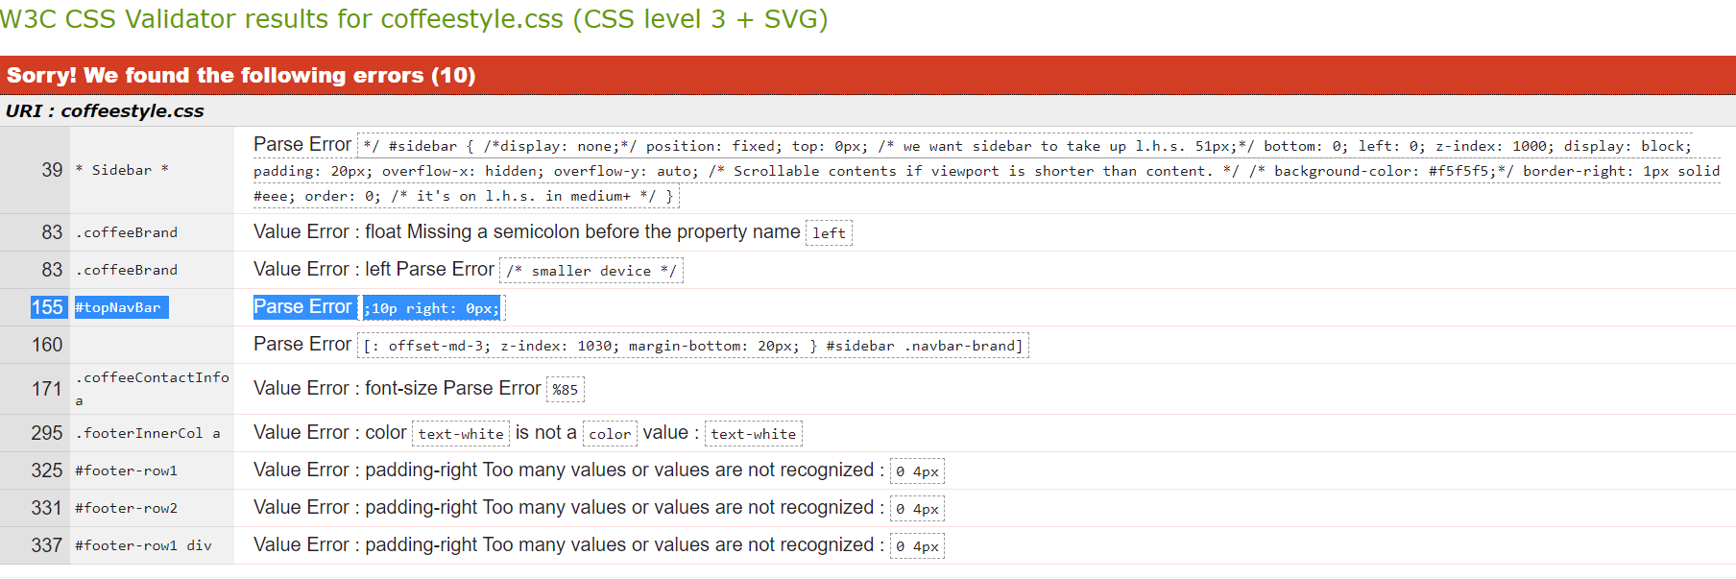

Line 39: there were non-matching */ */ a few lines above. Fix: match up the /* */

Line 83: needed to put in float: left; /* smaller device */ instead of float: left: /* smaller device */

Line 155: top: 0px;10p right: 0px; I replaced it by top 0px; right 0px;

Line 163: padding-left: x; X is not a valid value. I deleted the line.

Line 171: font-size: %85; I replaced this with font-size: 85%;

Line 295: replaced text-white with white.

325 and next 2 errors: When I replaced it with just padding: 0px 4px the spacing and borders were incorrect – I ended up deleting these rows – they were unnecessary.

After fixing the CSS errors I retested the page and found out that by fixing the errors I had broken the spacing/padding for the footer. So, fixed and retested.

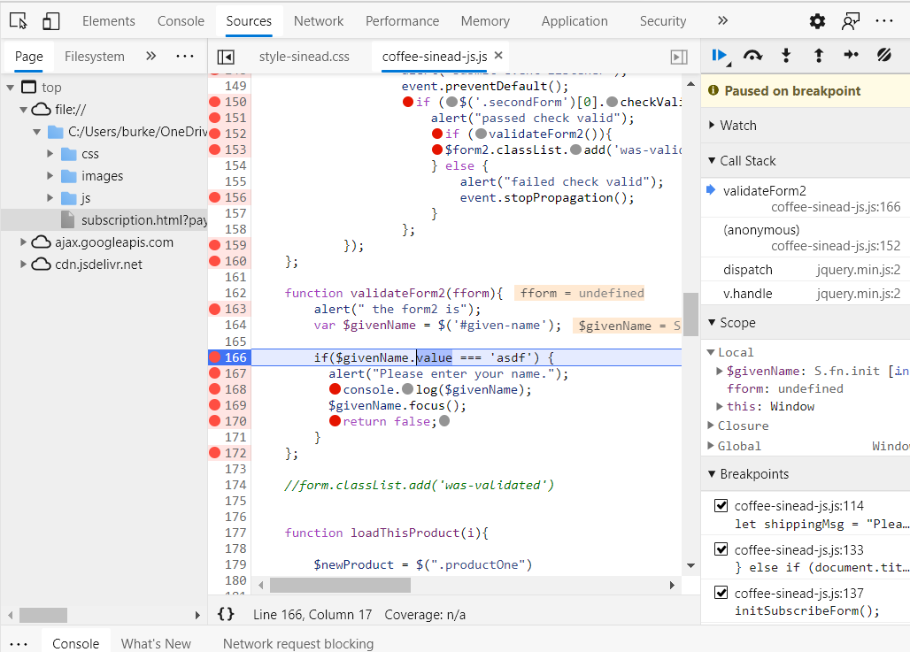

A really pesky bug. I had been looking at W3school DOM properties for forms and tried to use .value to access the value within the givenName variable. When used the debugger to look into the attributes of this object, sure enough value was one of them. But, the if statement failed every time. Eventually, I realised that I needed a jQuery method – mixing up Dom/jQuery – as $givenName was obviously a jQuery variable. So replaced it with .val() and it worked fine.

#### Issues & Problems:

Bug: I came across an incompatibility problem. I originally used jquery-3.5.1.slim.min.js from code.jquery.com. However, it didn’t support the function slideToggle(); so, I tested the google hosted jquery-3.5.1.slim.js and it worked perfectly!

Extract from shop-coffee.html file: *note google lib supported slideToggle();*

*<!--script src="https://code.jquery.com/jquery-3.5.1.slim.min.js" integrity="sha384-DfXdz2htPH0lsSSs5nCTpuj/zy4C+OGpamoFVy38MVBnE+IbbVYUew+OrCXaRkfj" crossorigin="anonymous"></script-->*

*<script src="https://ajax.googleapis.com/ajax/libs/jquery/3.5.1/jquery.min.js"></script>*

This was the console error message in Chrome developer:

shop-coffee.js:24 Uncaught TypeError: $(...).slideToggle is not a function at HTMLButtonElement.<anonymous> (shop-coffee.js:24) at HTMLButtonElement.dispatch (jquery-3.5.1.slim.min.js:2) at HTMLButtonElement.v.handle (jquery-3.5.1.slim.min.js:2)

|  |  |  |  |
| --- | --- | --- | --- |
|  | (anonymous) | @ | shop-coffee.js:24 |
|  | dispatch | @ | jquery-3.5.1.slim.min.js:2 |
|  | v.handle | @ | jquery-3.5.1.slim.min.js:2 |

## Interface quality

## Design patterns – 2 s

The index.html is the ***About page*** gives a brief introduction to Bean & Gone. It has a nice backdrop image which should draw the user to Bean & Gone. This page uses a side bar navigation design for level 1 navigation. In smaller screen sizes, the side bar navigation disappears and is replaced by a hamburger icon which toggles the display of level 1 navigation with items expanding to fill the width of the screen.

The Subscription page uses an bootstrap form design pattern to provide the user with a high level view of the options and tasks involved. It also uses a form design pattern with input design patters for input options.

The coffee-merchandise.html page uses a sidebar navigation design pattern. It also uses a shopping product page – “related products” design to showcase the list of coffee merchandise. Once the user clicks on the individual product it uses an e-commerce product information design.

The about page uses the bootstrap jumbotron design. The FAQ page uses the bootstrap accordion design (which proved difficult as we were using bootstrap v4.x and it was supported in v5.x – so, took a bit of work!).

## Professional in appearance and layout.

## Complexity

## Scripting and advanced technical skills

# Deployment

*\*\* This section should include information on your choice of deployment, as well as your websites URL and a screenshot of the live site* **

## JQuery Usage

## Website optimisation

## Section – SEO search engine optimisation

##### Every mages have an alt field for SEO <img> src= and alt=

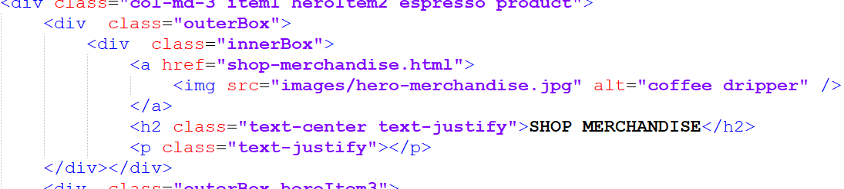

##### Each page has an appropriate title tag.



##### Use of keywords in domain name. Since Sinead had to deploy the site independently to be able to test out the use of cookies - I took the liberty of changing the site name so that it would include a keyword in the title – My individual site was deployed at: [Bean & Gone Coffee (sinead-dotcom.github.io)](https://sinead-dotcom.github.io/beanAndGoneCoffee/)

##### This URL includes the keyword “coffee”. As I was using cookies I needed a deployed site for testing and debugging my code so that I could get the cookies working.

##### Note cookies will not work properly on the local device with a browser!

##### For Keyword Planning we used the Google Keyword Planner tool.

##### Firstly, we needed a google email account. Then Sinead signed up for Google Ads for this account. This was an account just for this student project – [bearandgone@gmail.com](mailto:bearandgone@gmail.com).

##### Google Ads has a keyword planner. Sinead used the discover new keywords option. Here is an example of the keyword suggestions that appeared when one of the competitors’ URL was entered.

##### Each page has an individualised meta page description:

##### <meta name="description" content="Buy Coffee -we supply coffee equipment to businesses and individuals. Subscription & wholesale coffee."><!-- below 160/130 -->

##### Updated the meta description to include several of the key words from the SEO research and tried to keep them below the optimal length 160/130 on each page.

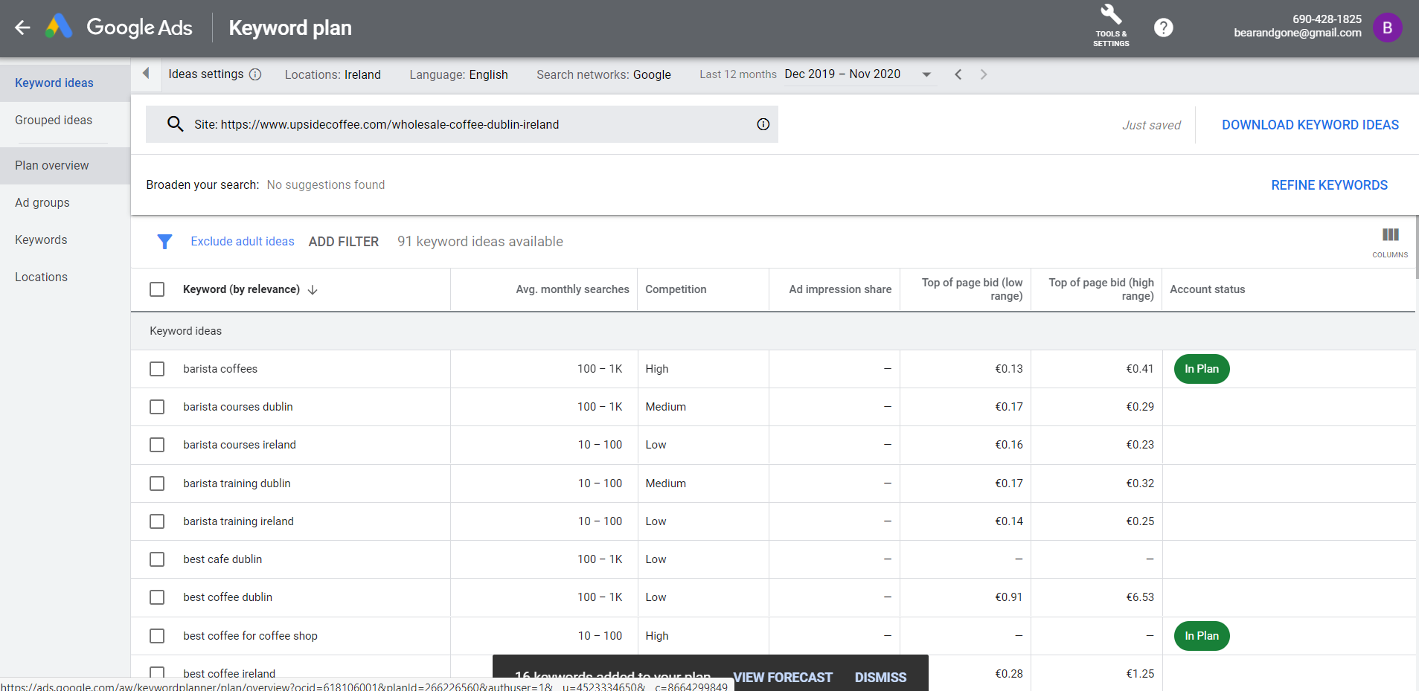

##### It was relatively easy to choose the highest google hit keywords from this site and add them to my plan.

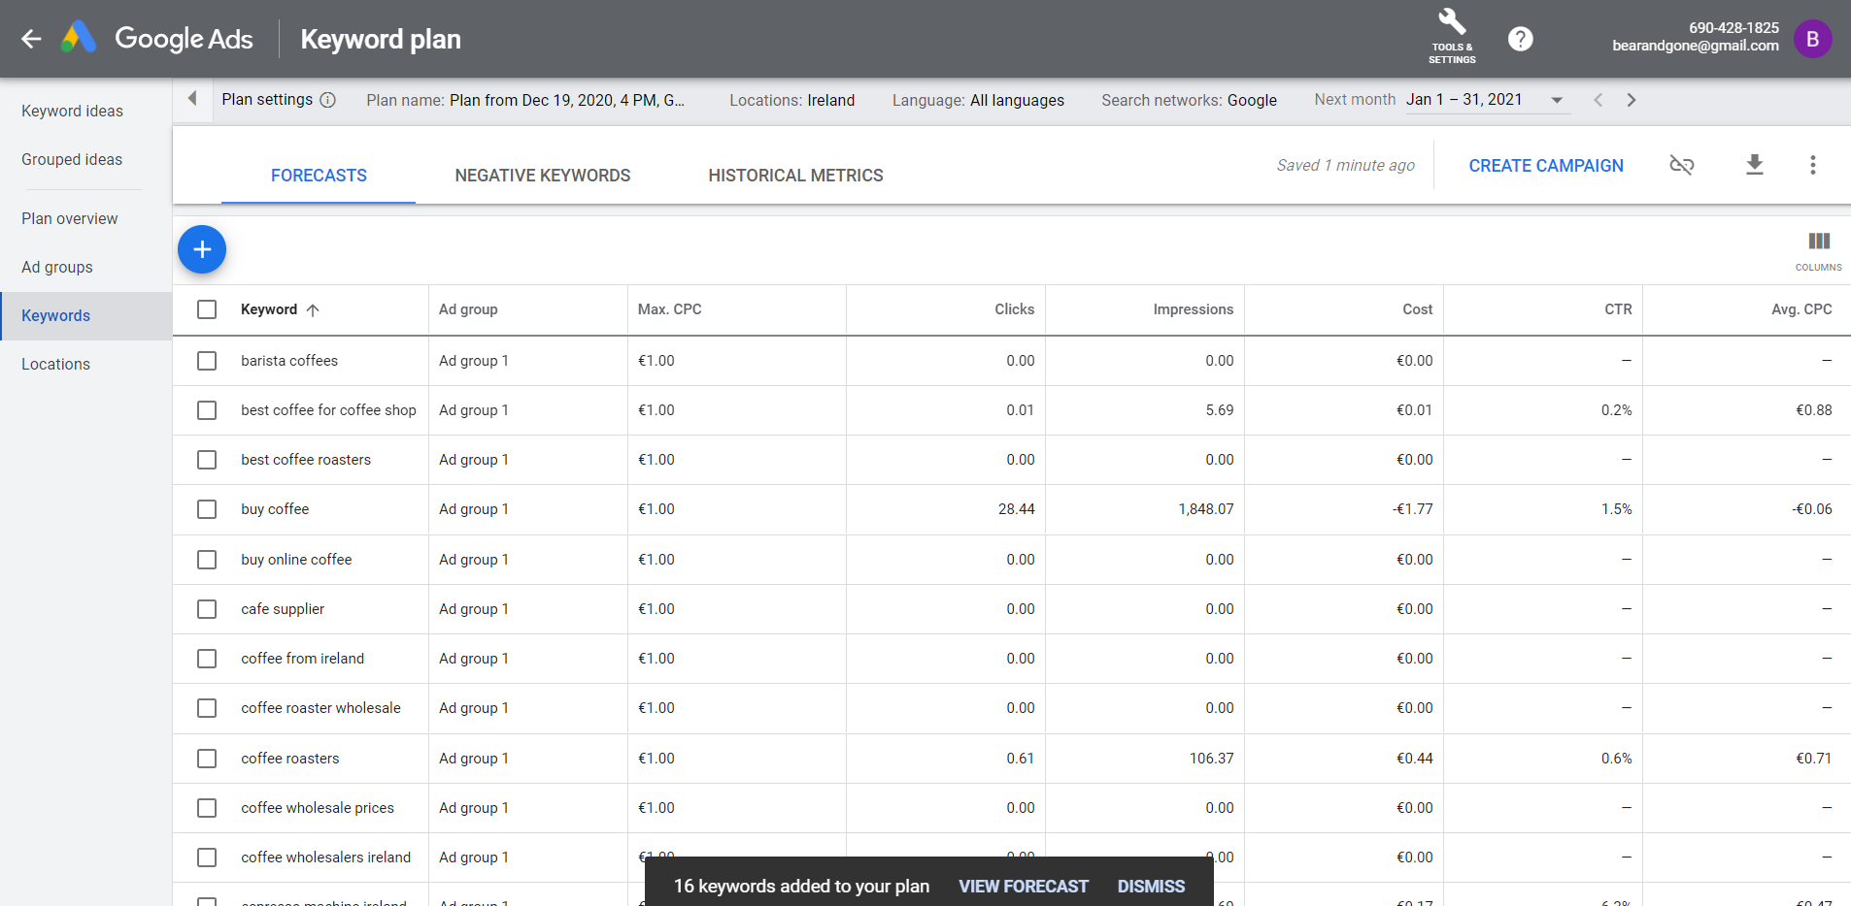

This gives me a good impression of how many “impressions” and “clicks” to expect on my home page for the “buy coffee” keyword. A really useful tool. Also, “buy coffee” keyword was the only one that really made a return on hits – from inclusion of the high words on 3 competitors web sites. Definitely, it is worthwhile investigating and putting effort into these keywords.

Google Ads would allow me to PUSH traffic to my website. Signed up for now to generate the information, will discontinue as will be charged to my credit card!

* We have provided good content. We even include information our ecologically sourced products in the FAQ page.

[FAQ Bean & Gone Coffee (sinead-dotcom.github.io)](https://sinead-dotcom.github.io/beanAndGoneCoffee/faq.html)

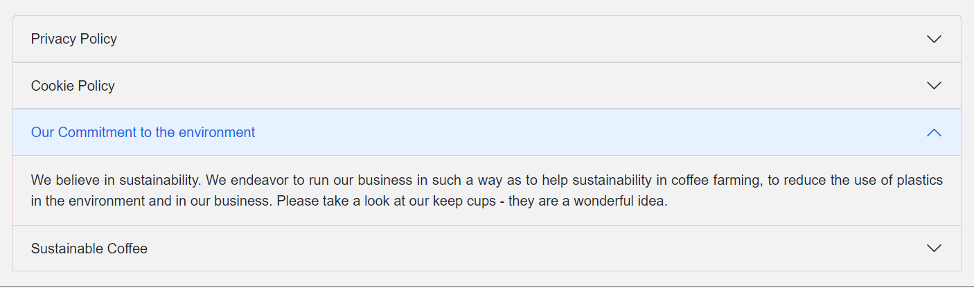

Meta robots tag used and crawling allowed.



* We have included a robots.txt and sitemap.xls file in the root directory.

The site was submitted to GOOGLE using an HTTP Get request as below:

Use the "ping" functionality to ask us to crawl your sitemap. Send an HTTP GET request like this:

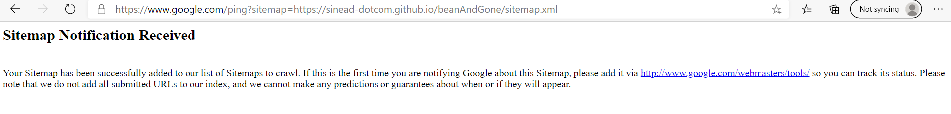

## Excellent use of optimisation etc?

# TOOLS used throughout

### Cloud based hosting service –

### Github/GitPages

No need for ftp tools like WinSCP for secure file transfer (SFTP) to cloud/hosting site, but downloaded and uploaded for practice.

### Version control system – Git

* Git bash and Git for Window for local commits/staging
* GitGUI (for push to cloud)

### Wireframes

Rob used Mockingbird software for the wireframes.

### Regular Expressions tools

We used <https://regexr.com> to help generate relevant regular expressions for validation in JS. It would be important to revisit these expressions at a later stage to include support for more international names.

### SEO TOOLS

The site was submitted to GOOGLE using an HTTP Get request as below:

Use the "ping" functionality to ask us to crawl your sitemap. Send an HTTP GET request like this:



### Microsoft Project

Microsoft project was used throughout for planning purposes and importantly to set deliverables and goals. Please see the project plan in the appendix.

### Validation Tools

W3C CSS Validator

W3.org HTML validator

### Testing tools

Use of the various browser’s developer debugging tool. It was helpful to set breakpoints and inspect the values of variables. The console log threw up various errors – mostly typo’s and syntax errors and file not found issues.

Use of console.log to help debugging jQuery/JS. It allowed me to inspect the vars and find out what they were – especially useful when had to figure out the children relationship for the cloned product <div>.

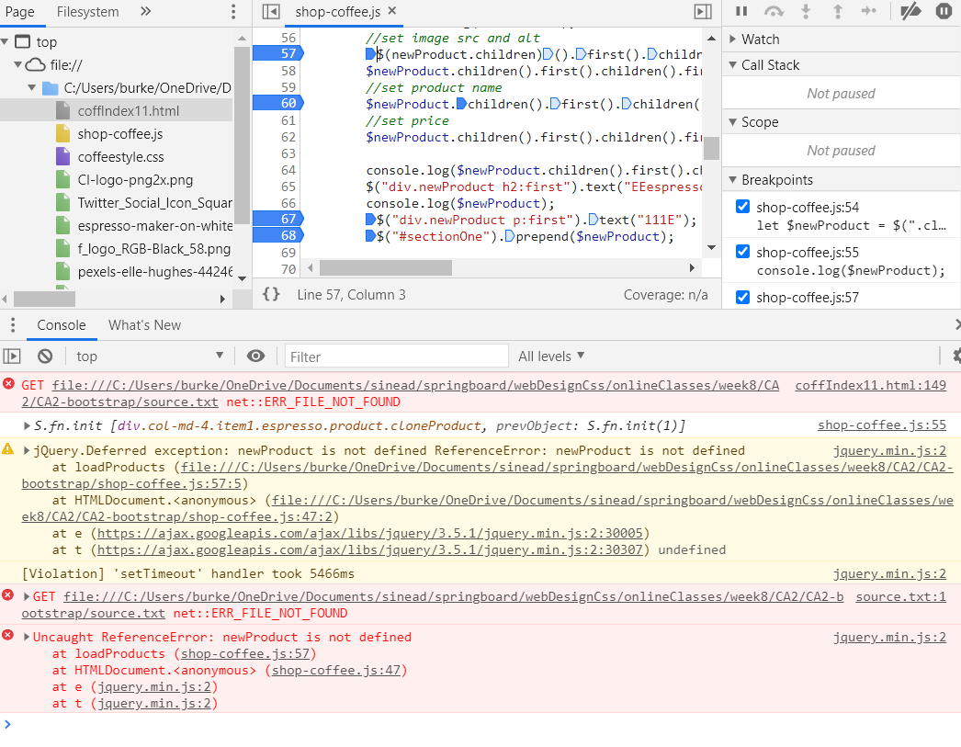

I had a lot of problems with syntax in jQuery/JS because I was only learning it. The debugger was invaluable, along with w3schools.

Above, I had changed the <img src> attribute so that it failed to load and I could verify that the <img alt> was set correctly.

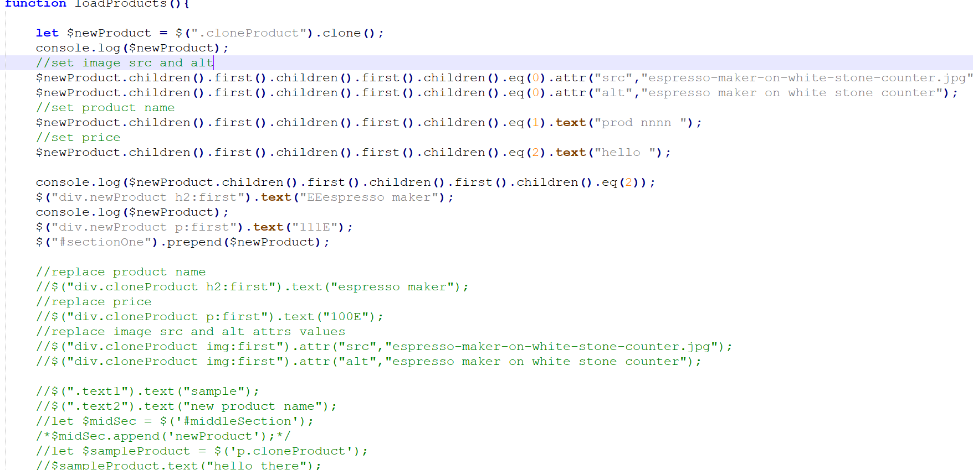

I also had a syntax error on $newProduct variable. The code above worked a lot better.

I came across an obscure problem that only showed up on Chrome.

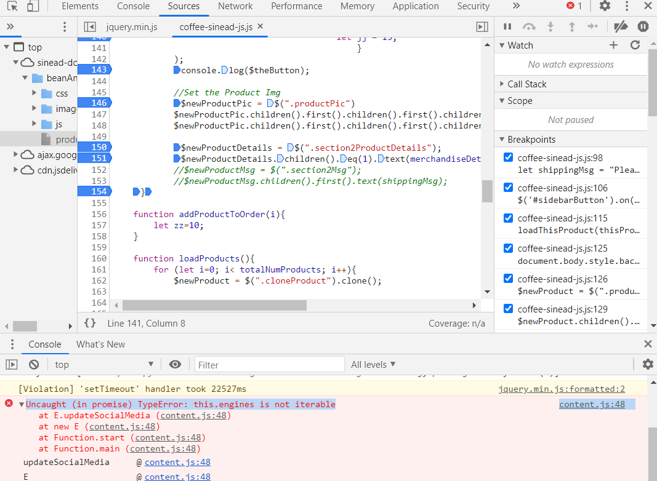

It seems that the McAfee Chrome extension is causing a problem. Naturally, I did not delete this extension. This wasn’t a problem with other browsers. This is worth further research.

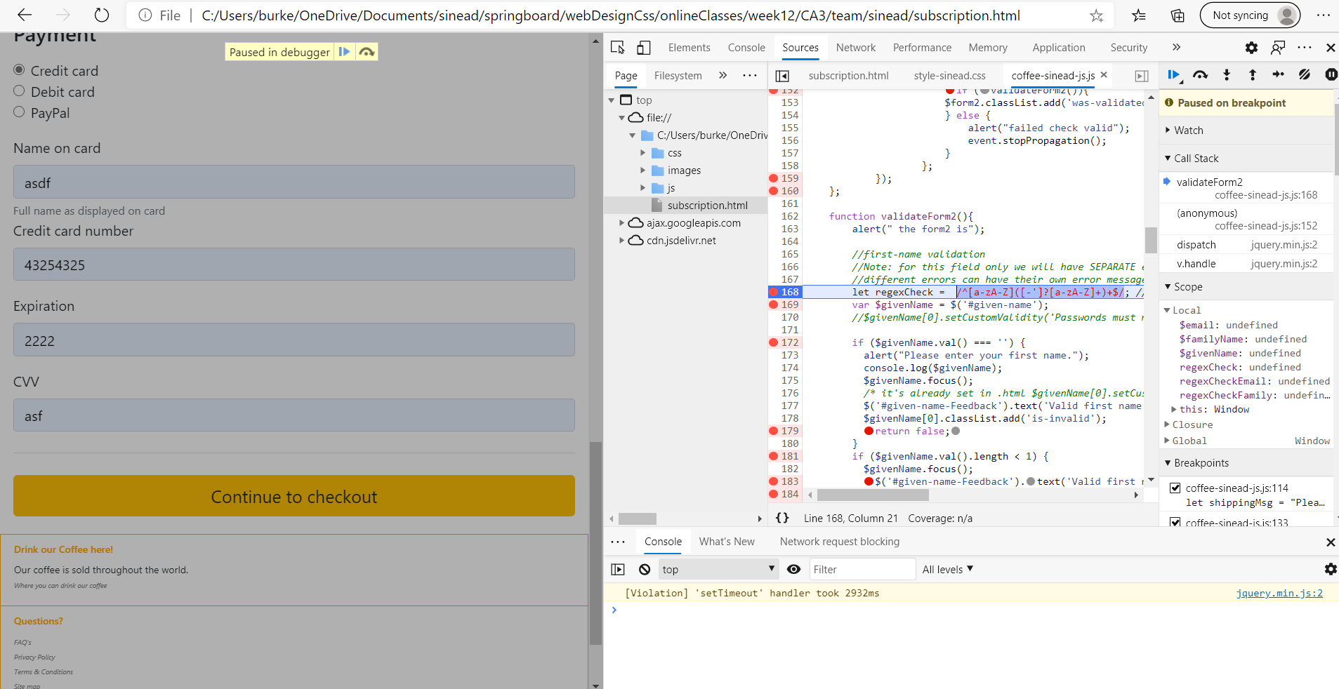

Above: going through the debugger to test out that each path works as planned – for each input field in the Subscripter.html page. This took ages as had to verify that the correct “if statement”/check was triggered. It would be a good idea to revisit this code and make it more compact. But, for the moment, it helps for testing purposes to have each individual test performed separately.

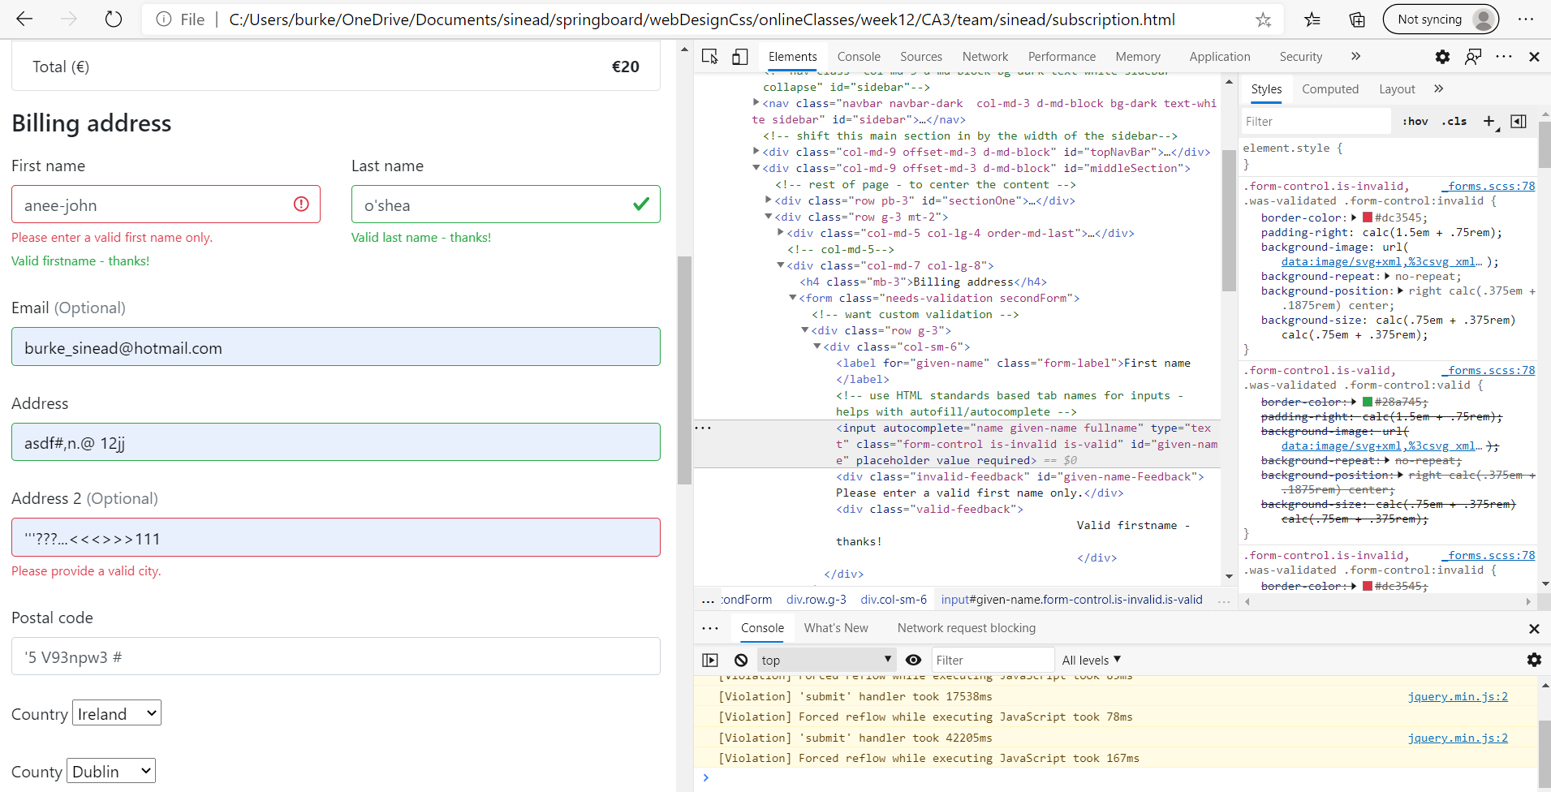

User testing turned up a funny scenario where both the valid and invalid error messages were turning up on the subscription.html form! I had to use the developer tools to figure out what was happening. The form-control had both is-valid and is-invalid as part of their class attribute! Needed have either one or the other – delete was required!

### SEO tools

### Performance tools

### Cookies tools?

Please note that first party only cookies are used in this project. They are used by the product merchandise page to store information about the product chosen and allow the merchandise product page to load the details for the correct product. They are also used to record items added to the cart. These cookies are stored for 1 day. They can be seen easily by going to your browser settings and searching for cookies for this the Bean & Gone web site address.

Please note that these are functional cookies only and not used for tracking purposes.

It was necessary to deploy this code independently of the group project, to test and develop the cookie functionality, as cookies do not work properly in the browser when the site is loaded locally.

The FAQ.html page includes Privacy statement and a Cookie Policy. Please note that these have been adapted from the **RTE web site** as it does an excellent job of describing these topics.

# Testing

** This section should include information on any user testing carried out on your website, i.e. how many people you tested it on, what tasks you asked them to preform, the results of testing, if you implemented any user suggestions, etc. **

## User testing

#### Devices

|  |  |  |  |  |
| --- | --- | --- | --- | --- |
| **Device type** | **Model Name** | **Software Version** | **Landscape** | **Portrait** |
| **Phone** | iPhone7 | 14.2 |  |  |
|  | iPhone 8 |  |  |  |
|  | iPhone 5s |  |  |  |
|  |  |  |  |  |
| **iPAD** |  |  |  |  |
|  |  |  |  |  |
| **PC** |  |  |  |  |
|  |  |  |  |  |
|  |  |  |  |  |
|  |  |  |  |  |
|  |  |  |  |  |
|  |  |  |  |  |
|  |  |  |  |  |
|  |  |  |  |  |
|  |  |  |  |  |
|  |  |  |  |  |
|  |  |  |  |  |
|  |  |  |  |  |

### Zoom testing

### Landscape/Portrait testing

### Accessibility testing

Form role=”form” allows someone with a screen reader to jump directly to the form by using the keyboard. It’s important for accessibility purposes.

Used labels for inputs – making it easier for someone with a disability to navigate through the form. Labeled and linked up with ID.

### Change of Font/Colour/Dark-Light mode testing

### Test Plan

### Test Results

### Feedback from Test Results

## Functional testing

## Automated Testing

## HTML/CSS/Java testing

## Cross platform testing

## Validation testing

## Responsive design testing

## Advanced testing tools

# Project Team

** How did the project team break up the tasks required?

Who did what tasks? Did everyone evenly participate?

Were there any team issues? How were these issues resolved? Etc. **

**Please note:** You will each be asked to individually peer review your team mates also

We started with a project plan using Microsoft Project tool. Rob came up with a great idea for a little coffee shop/roastery; with a coffee menu, bean delivery as well as accessories (coffee grinders etc.). Rob suggested 3 great sites as starting points: Coffeewerk and Press, Upside Coffee Roasters and 3fe.com. 3 names for the coffee shop/site included: “Rob’s House of Coffee”, “Bear Brew” and “Bean and Gone”.

We got to work getting a project research structure in place:

* Template Project Plan
* Template Project Report
* Template Persona
* Template site design/analysis document
* Template Research Questionnaire

Simultaneously we got to work setting up an infrastructure for the project development itself:

* Git for version control
* Teams group for easy and quick communication
* GitHub for hosting
* Test Hardware list for DevOps

Key decisions:

* Wireframing – Rob used MockingBird
* Framework: Bootstrap
* Version control: git
* Hosting: GitHub

Then we started the design/analysis phase for Coffee shop website project. It was all hands on deck, work through the problems and get pages working in stages.

# Conclusion

** Having finished the project, looking back, how did the project go?

Did you achieve what you set out to do?

Are you happy with the results?

Is there anything you might change if you had more time? Etc. **\*\***

## Rob

## Sinead

It was hard to keep track of MS word documents. GIT worked well as a version control for the source code. We had a doc directory to upload versions of the word and PDF documents – just in case we needed to fall back. We also used a OneDrive shared copy of the documents. It was a workable solution but not as seamless as possible. I would definitely like to research and understand better solutions to this problem .

I used cookies as a local storage solution for the Coffee Merchandise page – this allowed the Product page to load the correct product chosen from the Coffee Merchandise page. It was also used for the basket. I would like to use the Web Storage API next time. I would also like to use JSON/AJAX and server-side solutions for more complete functioning of the web site.

I would also have like to test the submit/payment functionality further with a transaction simulation using either PayPal/Stripe.

I would like to have included some security aspects to the project – like checking for sandboxing. I would like to have done more vulnerability testing – (CVE.mitre.org/cve) – to address more issues uncovered. As there was no backend server functionality in this project the security aspects were simpler.

# References / Appendix A

## Sineads references and sourced materials

https://www.citethisforme.com/guides/harvard/how-to-cite-a-book

Duckett, J., 2014. *Javascript & Jquery*. 1st ed. www.wiley.com: John Wiley & Sons, nc, pp.2-50.

Duckett, J., Ruppert, G., Moore, J. and Stone, E., 2011. *[Web Design With HTML, CSS, Javascript And Jquery Set]*. 1st ed. www.wiley.com: John Wiley & Sons, Inc., pp.4-485.

Myers, M., 2015. *A Smarter Way To Learn Jquery*. 1st ed. www.ASmarterWayToLearn.com: CreateSpace Independent Publishing Platform, pp.1-260.

Harmes, R. and Diaz, D., 2008. *Pro Javascript Design Patterns*. 1st ed. Berkeley, Calif.: Apress, pp.1-350.

W3schools.com. 2020. *W3schools Online Web Tutorials*. [online] Available at: <https://www.w3schools.com/> [Accessed 2 December 2020].

Cogan, S., 2020. *Part 4: Github Setup, Creating And Pushing To Repositories*. [online] Youtube.com. Available at: <https://www.youtube.com/watch?v=irijcQat95E> [Accessed 2 December 2020].

Validator.w3.org. 2020. *Ready To Check - Nu Html Checker*. [online] Available at: <https://validator.w3.org/nu/> [Accessed 2 December 2020].

jigsaw.w3.org. 2020. *The W3c CSS Validation Service*. [online] Available at: <https://jigsaw.w3.org/css-validator/validator> [Accessed 2 December 2020].

Yougov.co.uk. 2020. *Pret A Manger Launches Coffee Subscription Service | Yougov*. [online] Available at: <https://yougov.co.uk/topics/consumer/articles-reports/2020/09/09/pret-manger-launches-coffee-subscription-service> [Accessed 8 December 2020].

Statista. 2020. *Coffee Consumption Location 2019 | Statista*. [online] Available at: <https://www.statista.com/statistics/681659/coffee-consumption-location-united-kingdom-uk/#:~:text=This%20statistic%20shows%20the%20results,drip%20coffee%20in%20a%20caf%C3%A9.> [Accessed 8 December 2020].

Mark Otto, a., 2020. *Dashboard Template · Bootstrap*. [online] Getbootstrap.com. Available at: <https://getbootstrap.com/docs/4.5/examples/dashboard/> [Accessed 8 December 2020].

Mark Otto, a., 2020. *Bootstrap · The World’S Most Popular Mobile-First And Responsive Front-End Framework.*. [online] Getbootstrap.com. Available at: <https://getbootstrap.com/docs/3.4/> [Accessed 8 December 2020].

3fe Coffee. 2020. *Coffee, Equipment And Exclusive Wares | 3Fe Coffee*. [online] Available at: <https://3fe.com/> [Accessed 8 December 2020].

Upside Coffee Roasters. 2020. *Upside Coffee Roasters*. [online] Available at: <https://www.upsidecoffee.com/> [Accessed 8 December 2020].

Coffeewerk + Press. 2020. *Coffeewerk And Press*. [online] Available at: <https://coffeewerkandpress.com/> [Accessed 8 December 2020].

W3schools.com. 2020. *How To Position Text Over An Image*. [online] Available at: <https://www.w3schools.com/howto/howto_css_image_text.asp> [Accessed 8 December 2020].

W3schools.com. 2020. *How To Create An Image Grid*. [online] Available at: <https://www.w3schools.com/howto/howto_js_image_grid.asp> [Accessed 9 December 2020].

W3schools.com. 2020. *Jquery Slidetoggle() Method*. [online] Available at: <https://www.w3schools.com/jquery/eff_slidetoggle.asp> [Accessed 10 December 2020].

DIV, j., S.M, S. and Raheel, M., 2020. *Jquery Duplicate DIV Into Another DIV*. [online] Stack Overflow. Available at: <https://stackoverflow.com/questions/16068047/jquery-duplicate-div-into-another-div> [Accessed 11 December 2020].

W3schools.com. 2020. *Jquery Set Content And Attributes*. [online] Available at: <https://www.w3schools.com/jquery/jquery_dom_set.asp> [Accessed 11 December 2020].

W3schools.com. 2020. *Jquery Traversing*. [online] Available at: <https://www.w3schools.com/jquery/jquery_traversing.asp> [Accessed 11 December 2020].

jQuery, G. and High, J., 2020. *Get Second Child Using Jquery*. [online] Stack Overflow. Available at: <https://stackoverflow.com/questions/4727263/get-second-child-using-jquery> [Accessed 11 December 2020].

2020. [online] Available at: <https://codepen.io/AdamActual/pen/rvYrxN> [Accessed 11 December 2020].

Myers, M., 2015. *A Smarter Way To Learn Jquery*. 1st ed. www.ASmarterWayToLearn.com: CreateSpace Independent Publishing Platform, pp.126.

Mark Otto, a., 2020. *Jumbotron*. [online] Getbootstrap.com. Available at: <https://getbootstrap.com/docs/4.0/components/jumbotron/> [Accessed 12 December 2020].

W3schools.com. 2020. *CSS Background-Size Property*. [online] Available at: <https://www.w3schools.com/cssref/css3_pr_background-size.asp> [Accessed 12 December 2020].

Youtube.com. 2020. *Twitter Bootstrap - Part 1 - Sam Cogan*. [online] Available at: <https://www.youtube.com/watch?v=AK9UVBmYunk&list=PLccPlNFtq5uHnHBHvlhtIja2ChOK8f18h> [Accessed 12 December 2020].

Uiguideline.com. 2020. *UI Guideline*. [online] Available at: <https://www.uiguideline.com/reference-systems/gitlab-design-system> [Accessed 12 December 2020].

W3schools.com. 2020. *Javascript Cookies*. [online] Available at: <https://www.w3schools.com/js/js_cookies.asp> [Accessed 15 December 2020].

js.foundation, J., 2020. *Event.Data | Jquery API Documentation*. [online] Api.jquery.com. Available at: <https://api.jquery.com/event.data/> [Accessed 16 December 2020].

Mark Otto, a., 2020. *Collapse*. [online] Getbootstrap.com. Available at: <https://getbootstrap.com/docs/4.0/components/collapse/> [Accessed 16 December 2020].

Tutorialrepublic.com. 2020. *How To Redirect To Another Web Page Using Jquery / Javascript*. [online] Available at: <https://www.tutorialrepublic.com/faq/how-to-redirect-to-another-web-page-using-jquery.php> [Accessed 16 December 2020].

Cloud Four. 2020. *Autofill: What Web Devs Should Know, But Don’T*. [online] Available at: <https://cloudfour.com/thinks/autofill-what-web-devs-should-know-but-dont/> [Accessed 17 December 2020].

About.rte.ie. 2020. *Policies And Guidelines – About RTÉ*. [online] Available at: <https://about.rte.ie/reports-and-policies/policies-and-guidelines/> [Accessed 18 December 2020].

About.rte.ie. 2020. *Cookie Policy – About RTÉ*. [online] Available at: <https://about.rte.ie/reports-and-policies/cookie-policy/> [Accessed 18 December 2020].

Mark Otto, a., 2020. *Modal*. [online] Getbootstrap.com. Available at: <https://getbootstrap.com/docs/4.5/components/modal/> [Accessed 19 December 2020].

## Robs referenced and sourced materials

Asdf

# Appendix B: Project Plan

MS project was to assist with project planning and to keep the project on track.

